A flood management high level review
for the Broads Climate Partnership
Produced by consultants CH2M, October 2016

Executive summary
The eastern half of Norfolk has been influenced over many hundreds of years by the natural processes of erosion and flooding and by patterns of human intervention. The environment and economy in this low-lying area are vulnerable to the impacts of sea level rise and a changing climate, and highly dependent upon flood defences.
Currently, flood and coastal risk management (FCRM) for the area includes three major flood defence strategies, covering: The coastline from Eccles to Winterton; Great Yarmouth; and the Broadland rivers.
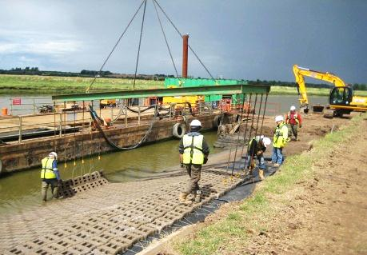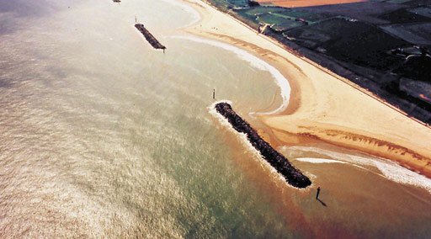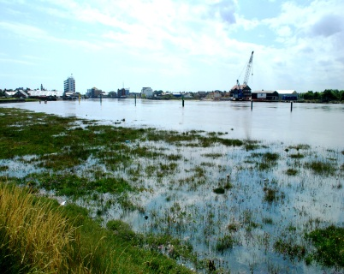
Photos: BFAP flood defence works; coastal defences at Winterton; flooding at Great Yarmouth
In recent years, several million pounds a year has been spent on maintaining and improving these flood defences in line with the relevant strategies, all of which started more than 20 years ago. While many of the defences currently provide the protection required, those in some locations are moving towards a point where they will need more attention in the years to come. We therefore need to start planning now for the potential works ahead, to make sure the necessary planning approvals and funding are in place.
The Flood Management High Level Review brings together existing information as a starting point for discussion on future options for flood risk management. It highlights the following issues:
- Eccles to Winterton: The policy here is to hold the existing flood defence line so that the position of the shoreline remains (known as ‘hold the line’). However, this is ‘conditional’ from 2055 onward, as external changes between now and then – political, environmental, economic, social and technological – may well alter our assumptions and the flood defence options available to us. We therefore need more evidence to help inform our long-term decisions for this area.
- Great Yarmouth tidal walls: If the present line of flood defence is to remain, considerable investment will be needed to address the poor and continually deteriorating state of the quay walls that support the majority of the flood walls. A major consideration is how these works would be funded.
- The Broads: At the conclusion of the present Broadland Flood Alleviation Project contract in 2021, the flood defences along the Broadland Rivers will have a remaining life of 5 to 10 years. Currently, there are no plans in place on what will be done after this time. Again we need to assess what is technically and financially possible and practical to inform future decisions.
- A tidal barrier is one option as part of a future flood defence system. There are many differing opinions about what a barrier should or could provide, but this option needs further considering.
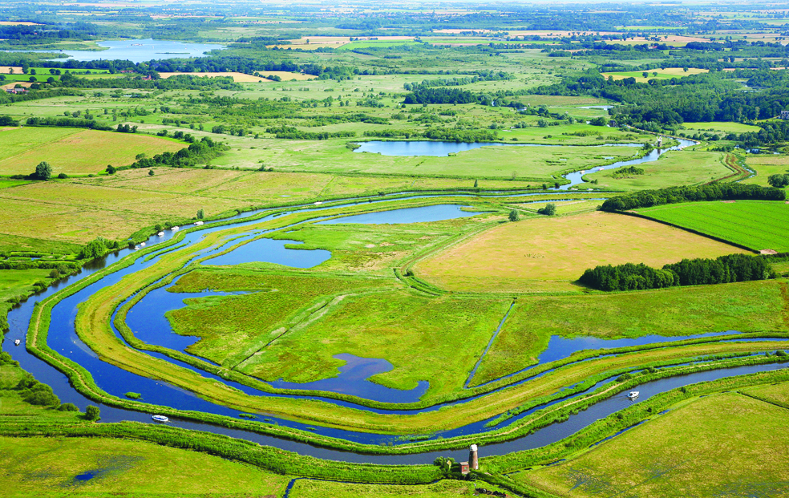
Photo © Mike Page
The conclusion of the Flood Management High Level Review is that there is a clear need for a strategic overview of flood risk management policies in the whole area. This should include:
- Flood and coastal risk management and the interrelationship between tidal flood risk and flood risk from rivers to the large area of low-lying land in this region; and
- Wider issues - such as maintaining the protected landscape of the Broads and its freshwater status, and sustaining farming and local businesses - that will determine how the area is used.
A single integrated strategy, combining the three flood and coastal risk management strategies currently in place, would help reflect the importance of flood defence management for the wider environment and economy. It would also help us to consider options and make decisions that take account of all impacts and benefits, and avoid potentially incompatible approaches.
We need to look at changes since the current strategies were implemented and decisions taken previously. Changes in funding and contributions to flood defence schemes will set new challenges and opportunities, while predicted changes in climate and sea level may alter perceptions of risk, damage and opportunities. We may also have to consider how we manage change, as maintaining things as they are now may not be the solution.
The economic benefit of protecting land and properties from flood risk in the area is estimated at between £900m and £1200m (at today’s value), while the total cost of continuing to protect these assets over the next 50 years is likely to be around £500m. However, under current funding rules, central government grant aid (Food Defence Grant-in-Aid or FDGiA) will not meet all of that cost. It is possible that up to two-thirds of this amount would need to be found through local contributions from any source. The level and potential source of such contributions is obviously of critical importance in determining the flood management options available.
This high level review is the first step towards developing options and a future flood management strategy. The information and conclusions in the full report are a starting point for discussion with organisations and communities about future defences and funding.
There are many points still to be considered that could have a major bearing upon the direction of this strategy, and we are not yet in a position to make firm decisions for longer term flood management. The interrelationships between the three areas need more detailed analysis, and joint objectives need to be discussed and agreed by the range of interested stakeholders. A first step is to reduce the multiple and complex flood management options and outcomes to something more manageable, so that we can consider them in more detail.
In summary, the key conclusions of this review are:
- The environment and the economy of the local area (Eccles to Winterton, Great Yarmouth and the Broadland Rivers) are fundamentally reliant on flood defence. While the current approaches to flood and coastal risk management (FCRM) are providing the necessary flood protection, vital decisions must be made about the direction of longer term flood risk management before further significant investment can be justified.
- While the current flood risk management strategies all need updating, the interrelationship between them suggests that a single overarching strategy would be the best way forward.
- We need to know what needs investigating and evaluating before an informed, evidence based FCRM strategy can be developed. This work should proceed as soon as possible.
- Funding has changed in recent years, and new and possibly significant sources of funding will have to be found to help to maintain and replace flood defences in the future.
- We should be prepared to challenge current assumptions and flood defence approaches, and consider a wider range of options for managing flood risk in the future. We may also need to accept that maintaining things the way they are now may not be an option.
- We need to involve the wide and diverse range of stakeholders – including residents, local businesses and visitors - who will be interested in, or affected by, flood management decisions for the area. This means working together to develop shared expectations and goals for flood management that are both realistic and achievable.
To see the full report and more information, visit http://www.broads-authority.gov.uk/ looking-after/ climate-change/broads-community or contact Simon Hooton, Head of Strategy and Projects, Broads Authority, 62-64 Thorpe Road, Norwich NR1 1RY;
tel. 0163 610734; email broadscommunity@broads-authority.gov.uk
October 2016

