

Adapting the Broads to cope with the weather

*The Broads Authority and its partners are looking at adaptation to get the best for the Broads from predicted climate change and sea level rise.*

*Through the* ***Broads 0Community*** *project, we are working with stakeholders to share conclusions to date and common ideas on the next steps. The background information and ideas in this paper are therefore still being formed and are open to debate and change.*

**WHAT CHANGES ARE EXPECTED?**

* Warmer, drier summers; intense rainfall periods possible; more cloud free days
* Winters that may be a little  
  wetter but with more intense periods   
  of rain and a little warmer
* More extreme weather events,   
  both in terms of frequency   
  and intensity
* Steadily rising sea levels

The latest predictions relevant for the Broads suggest that, by the 2080s, we could expect the weather in Spring, Autumn and Winter to be more like it would be 2-3 months later in the year. For example, this could mean June weather conditions in March.

The future *average* temperature in Summer would be most similar to the current average *maximum* temperature. Although an average August maximum temperature of 26°C is not that great, the number of days exceeding 30°C seem likely to increase and days that would have been 30°C could be   
34-36°C.

The average January stream (water) temperature might be like those now occurring in May, and May/June temperatures more like those in August. Winter sea temperature is projected to be like that currently experienced in May.

This information comes from 2014 research by Dr. Jeff Price at UEA, updating work first completed for the Broads Authority in 2003.

**LESSENING THE SCALE OF CHANGE**

Although this leaflet looks primarily at ‘adaptation’ needs, it is important to remember that the build-up of greenhouse gases in the atmosphere continues to change our climate. The more we can do to limit emissions now and in the immediate future, the lower the rate and range of change that   
will happen.

Part of the adaptation process is therefore to find ways of rapidly decreasing our reliance on fossil fuels (such as coal, gas and oil). Adaptation planning helps that change as well as making us more resilient to whatever challenges the weather brings us in   
the future.

PARISH ISSUES WITH A changING CLIMATE



**BROADS ADAPTATION PLAN**

The Broads Climate Partnership has developed an adaptation plan for the area. A central idea is to take a ‘Climate Smart’ approach where the projected climate changes are related to the important assets and qualities in people’s lives and localities to see how they might be affected.

This enables you to list your vulnerabilities to climate change. You can then consider what could be done to minimize adverse or maximize beneficial impacts. This creates adaptation options that can be researched to see what is feasible, most effective, economically or technically viable and brings the best benefits.

It is possible that none of the options seem plausible. You may then choose to change the objective/goal and look again at adaptation options to see if the choices   
are better.

**WATER MANAGEMENT**

The Climate Adaptation Plan highlights that for the Broads, the future management of water is especially important – something also picked up the in the National Adaptation Programme.

Later in this leaflet we look in more detail on the main options regarding flood management as it seems likely that new approaches will be required to cope with the likely conditions being projected.

As future climate impacts in East Anglia retain a level of uncertainty it will also be important to consider issues around periods of drought and how we can retain the necessary level of water quality (especially as treating poor water quality utilises a lot of energy which currently releases more carbon dioxide).



Flooding impacting in the community and in the garden

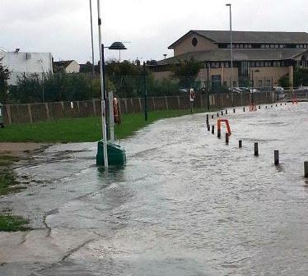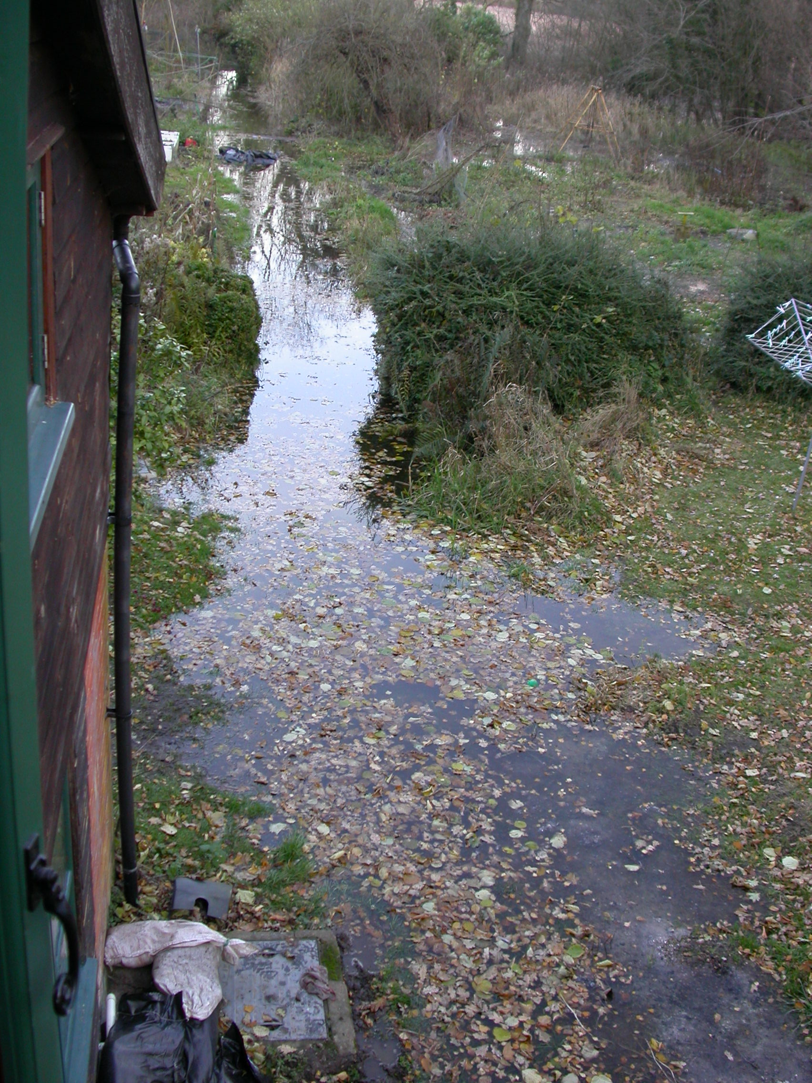

**ADAPTATION OPTIONS**

Sometimes it is easy to see how you might adapt – though often it might be important to cast your thinking wider and consider fresh approaches.

As adaptation planning may cover several decades there could be new solutions achievable in the future. Part of the approach is therefore to try and keep as many options open as possible. At the same time it is also worth remembering that acting now may well save money in the long run.

The table below summarises the kinds of responses that may be worth thinking about in more detail.



|  |  |  |  |  |
| --- | --- | --- | --- | --- |
| *Style of response to change* | *Change the*  *management* | *Change the technology* | *Relocate assets* | *Take no action* |
| *Resist change, make alterations to keep things same* | *✓* | *✓* | *X* | *X* |
| *Accept change, make no alterations* | *X* | *X* | *X* | *✓* |
| *Accept change, make alterations to get best from situation* | *✓* | *✓* | *✓* | *X* |
| *Accept change, alter goals/strategies/objectives* | *✓* | *✓* | *✓* | *(✓)* |

|  |  |
| --- | --- |
| **Predicted change** | **Possible/probable impacts** |
| Wetter, warmer winters | Longer tourism season  Frost damage to assets less likely  Periods of poor access due to wetness  Grass and other vegetation likely to grow for longer |
| Drier, hotter summers | Hotter summers promoting more outdoor living  Longer tourism season  Work in middle of day becomes less tolerable; vulnerable people at greater risk of heat waves  Stress on water supplies – hose pipe bans more likely  Lower water levels in the waterways possible  Impacts on buildings and other infrastructure |
| Extreme events | Damage to infrastructure and assets  Greater safety threats to be accommodated in emergency plans  Possible impacts on delivery /supply/ storage of resources  Flood risk – damage, accessibility, time to get back to normal |
| Sea level rise | Water table held higher for longer  Flood risk – damage, accessibility, time to get back to normal |
| Other | New products and services required / demanded  Different investment / maintenance parameters need to be developed for community assets |
| Impacts with generally positive outcomes  Impacts with generally negative outcomes  Impacts with both positive and negative impacts | |
| **Please do send us your thoughts on whether this table is helpful**  **or how it could be improved** | |

**ENVIRONMENTAL CHANGE AND YOUR PARISH**

Relating the predicted environmental changes to the special features and qualities of the Broads, some conclusions may be made about the most important aspects for parishes to consider. A preliminary list may include:

**DEALING WITH FLOODING**

As more frequent and larger scale flooding is a likely consequence of a changing climate the Broads 0Community is fostering the debate on the best way to manage the situation.

There are three general ways of dealing with this vulnerability:

Carrying on as normal

In this approach we tend to slowly upgrade flood defences over time especially in response to a flood event

Seeking to control and restrain the water

Here the emphasis is on engineered solutions with walls and barriers being built to keep water out, though as it has to go somewhere the interventions may cover extensive areas.

Allowing water to find spaces and dissipate

This accepts that on occasions there will be excess water that is allowed to go into, and onto, areas that can cope such as washlands. It also tries to find natural ways of holding water back and allowing it to infiltrate into the ground.

**WHAT DO YOU THINK IS THE BEST WAY TO GO FORWARD WITH FLOOD MANAGEMENT?**

Broads 0Community wants to know what people think about these scenarios to help inform the development of appropriate policy and practice. Which approach would help your parish? Would you be interested in learning more and seeing how you could help your community? More information can be found on the web site (details below) and this will slowly grow as ideas are shared.

Current policy is designed to create an acceptable coping regime. As the impacts of a changing climate and rising sea level start to really influence our environment this is likely to need to change – and we need to start planning now. Significant barriers to retain freshwater will be expensive and technically challenging; finding space for water will require different land management choices by landowners and probably new ways of getting a financial return be it through new crops or support payments.

**Please share your views with the Broads 0Community. We will draw them together and use them as we develop our plans for the future of   
the Broads.**



**JOIN THE DEBATE**

Broads 0Community wishes to help ‘early innovators’ to develop their adaptation consideration and planning. If you would like further advice and support, or have points you wish to share about adaptation planning - and especially the choices over flood management in the future - please contact Simon Hooton /Broads 0Community.

**Information**

Information about the Broads 0Community project, including Dr Price’s report, is on the Broads Authority’s website at www.broads-authority.gov.uk/managing/climate-change

**Getting in touch**

Email: [broadscommunity@broads-authority.gov.uk](mailto:broadscommunity@broads-authority.gov.uk)

Tel: 01603 756025

Post: Broads Community, c/o Broads Authority, Yare House,

62-64 Thorpe Road, Norwich, Norfolk NR1 1RY

Jun 2015