Broads Drained Marsh Strategy

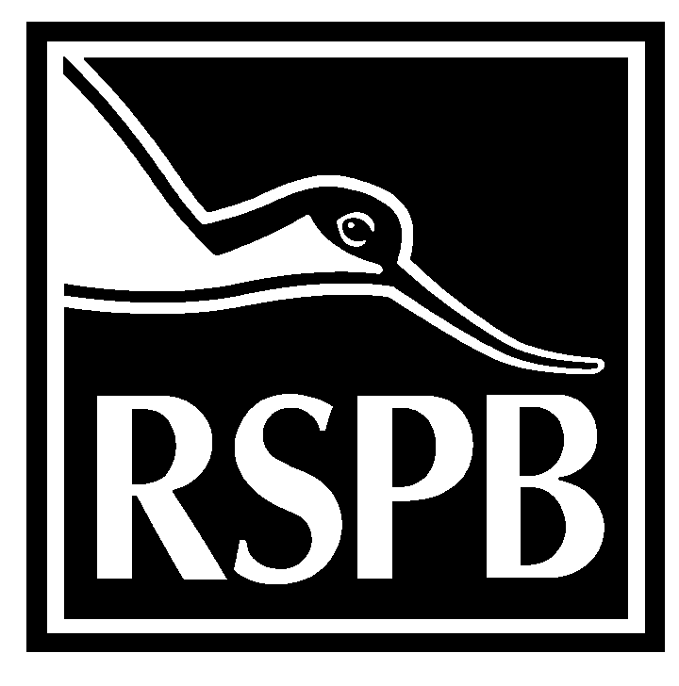
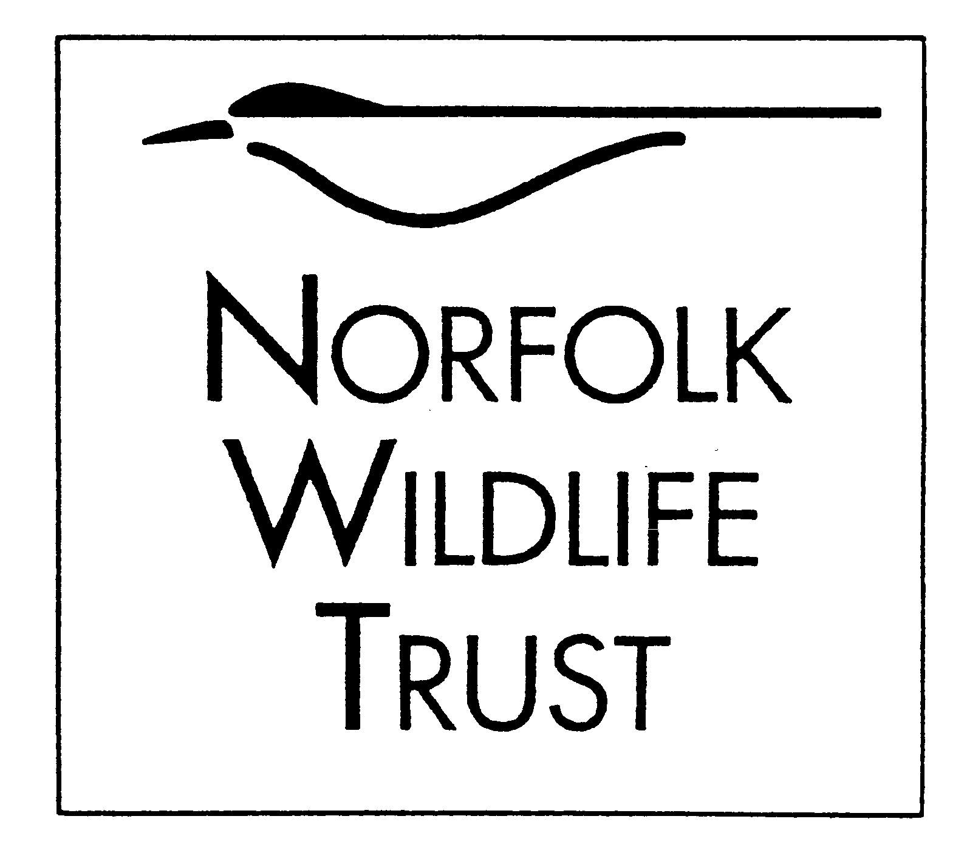
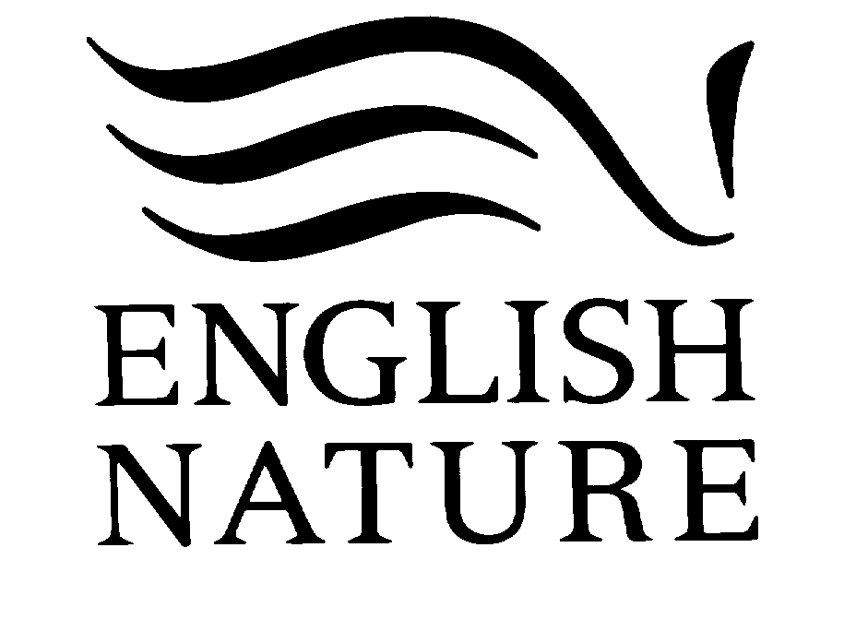


July 2001
wpo\np\drainedmarsh\5105

Contents

1 Introduction 2
1.1 Context 2
1.2 Aims 3
1.3 Partnership 3
2 History of the Broads Drained Marshes 3
3 Present wildlife values 5
3.1 Wintering waterfowl 6
3.1.1 Internationally important populations 6
3.1.2 Nationally important populations 7
3.2 Ditch flora 7
3.3 Plant communities 7
3.4 Plant species 8
3.5 Invertebrate communities and species 9
3.6 Vertebrates (excluding birds) 10
3.7 Breeding wildfowl 11
3.8 Breeding waders 11
4 Key issues and threats 11
4.1 Nutrient enrichment / saline intrusion 11
4.2 Availability of water 11
4.3 Flood defence 12
4.4 Water management 13
4.5 Agricultural practices 14
4.6 Human impacts 15
4.7 Introduction of alien/non-native species 16
4.8 Lack of detailed vision 16
5 Nature conservation vision for the drained marshes 17
Objectives 18
Overall aim 18
International objectives 18
1 Internationally important wintering waterfowl populations 18
2 Fen meadow communities 18
3 Internationally important dyke communities 20
National objectives 22
4 Nationally scarce plants/communities 22
5 Breeding waders 23
6 Breeding wildfowl 25
7 Nationally important wintering wildfowl populations 26
8 Priority invertebrates 27
9 Dyke communities of national importance 28
10 Water voles and otters 30
Biodiversity Action Plan Habitat Re-creation objectives 31
11 Coastal and floodplain grazing marsh 31
12 Reedbed 32
13 Wet Woodland 33
6 Framework for delivery 34
Glossary 39
Appendix 1 41
Broadland dyke aquatic endgroup classifications 41

1 Introduction

1.1 Context
The Broads Drained Marsh strategy is the second of three management strategies produced to aid the implementation of the policies, objectives and targets set out in the UK Biodiversity Action Plan (BAP), the Broads Plan and The Broads Natural Area Profile (NAP). The linkages between the plans are set out below:

National |  |  | Biodiversity  Action Plan
Broads | Natural Area Profile  (Advisory) |  |  |  | The Broads Plan  (Statutory)

Working
Strategies

Fen Management  Strategy |  | Drained Marsh  Strategy |  | Rivers & Broads  Strategy

The UK Biodiversity Action Plan sets out clear national objectives and targets for priority habitats and species. These have been translated into local objectives and targets by local Biodiversity Action Plans. Local BAP initiatives are already underway in Norfolk and Suffolk.

The Broads Natural Area Profile sets out the long-term conservation objectives for the area and identifies the changes needed to achieve the targets set out in the Biodiversity Action Plans.

The Broads Plan, published in 1997, is the statutory document identifying the Broads Authority’s management policies for the Broads area until 2002.

The Broads Drained Marsh strategy and its companion documents, the Fen Management Strategy and the Rivers and Broads Strategy, magnify the policies, objectives and targets set out in the BAP, NAP and Broads Plan and provide a clear basis for the co-ordination of management projects and the allocation of resources.

1.2 Aims
The Broads Drained Marsh Strategy is a working nature conservation document which provides a framework for co-ordinating the activities of land owners and managers, conservation bodies and other organisations involved in land use in the Broads Drained Marshes.

The Broads Drained Marshes are highly managed habitats and in some areas intensively farmed. The Drained Marsh Strategy is primarily a strategic document as opposed to highly prescriptive.

The strategy will:

- cover all habitats within embanked, drained floodplains within the Broads Natural Area, with the exception of fens which are covered by the Fen Management Strategy.
- set out objectives, targets and the actions necessary to maximise the key nature conservation features of the Broads drained marshes
- set out objectives, targets and the actions necessary to achieve habitat creation goals for grazing marsh and reedbed.

This strategy is a 10–year document and will be reviewed after five years.

The strategy recognises the importance of agricultural management in achieving the objectives. Although the strategy is first and foremost a nature conservation document, attempts have been made to ensure that the recommendations do not conflict significantly with the economic agricultural management of the drained marshes.

1.3 Partnership
The strategy has been prepared by a partnership comprising English Nature, the Broads Authority, the RSPB and the Norfolk Wildlife Trust. Comments from a wide variety of stakeholders, including farmers and their representatives, specialist ecologists and local authorities, have been invited on earlier drafts.

2 History of the Broads Drained Marshes
Historically the Broads comprised an extensive estuary system. In its lower reaches and close to the river channels, mudflats, saltmarsh and upper saltmarsh grassland would have been present. In the rivers’ upper reaches, tributaries and floodplain fringes, where freshwater conditions predominated, reedbeds and various fen vegetation types would have thrived. This historical pattern of vegetation is reflected in the various soil types found within the drained marshes, with clay and silt soils in areas previously under the influence of the brackish river system, and peat soils where freshwater predominated. However, the pattern of freshwater and brackish influence has not been static throughout history, hence in some areas the soil consists of alternate layers of clays, silts or peat. The majority of peat soils have been subject to marine inundation in the past and therefore contain concentrations of iron sulphate. These peats, when drained release sulphuric acid and iron hydroxide, and are consequently referred to as potentially ‘acid’ sulphate soils.

From the 13th century marsh reclamation started. Sea levels at that time were about a metre below present. Initially sheep grazing predominated, however by the 16th century there was a move to cattle. New areas were claimed and improvement to existing flood banks continued into the 16th century, driven by increases in sea level rise and a wish to increase agricultural production. By the early 18th century, the drained marshes were managed much as they are today, in that all land drainage had been completed and they were predominantly grazed by cattle, although recent agro-economics has produced a shift towards sheep grazing. The clay and silt areas were easiest to drain, the peaty areas were far more difficult, requiring more drains and resulting in smaller field sizes. Very wet spring fed sites and areas of fen and carr woodland along the marsh fringe that were impossible to drain were isolated from the claimed marshes by the cutting of landspring ditches and the use of high water carriers. Examples that exist today include Carleton Beck and the Hassingham Fleet.

Enclosures took place during the early 19th century, and this paid for improvements to the land and drainage infrastructure. Pre-enclosure, transient flooding occurred frequently due to the inefficiency of land drainage pumps, enabling the area to support huge numbers of waders, wildfowl and rare breeding birds such as the spoonbill, now extinct as a breeding species in the Broads. After enclosure, bird populations declined markedly, as drainage was efficiently controlled and flooding became rare. Prior to 1820, ruff had been a common breeding bird on the marshes. However, by 1827 it was becoming increasingly rare and by 1833 was locally extinct. The cause of this decline can be attributed to improvements in drainage and the destruction of the old washland areas with their associated wetland habitats. The plants also declined in this period with some species extinct by 1830, for example marsh fleabane Senecio congestus, and many others confined to a few small isolated sites, species such as grass of Parnassus Parnassia palustris and adder’s tongue Ophioglossum vulgatum. Saltmarsh plants and habitat were lost as a result of embankment including plants such as sea clover Trifolium squamosus, while others such as the nationally rare pedunculate sea purslane Halimone pedunculata survived possibly until the early 20th century.

The 20th century saw further major improvements of the drainage infrastructure driven by the wish to maximise agricultural production and was achieved through technological developments. In 1913, the first diesel pump was installed. During the 1930s, the 18 Internal Drainage Boards within the Broads came into existence and during the late 1930s and 1940s electrical pumps became widespread. The majority of grass marshes were ploughed and reseeded to improve their agricultural productivity. These developments led directly to a decline in bird numbers and the loss of the remaining traditional washes. Between the mid- 1960s and the mid-1980s there was a move towards further intensification and arable usage, with the associated lowering of water tables. Until this time the arable crops were grown under a similar water regime to that of the grazing marshes. In the past water tables were kept high throughout the year, and during the winter, flash flooding occurred or washland areas came into use. More effective drainage lead to the lowering of water tables throughout the drained marshes. Lower water tables, rising sea levels and deteriorating floodbanks resulted in many areas in the lower river valleys becoming more saline as the saltwater intruded further up the river system, while in the middle and upper valley ditches become more eutrophic from the influences of nutrient rich river water. This in turn partly accounts for the observed loss in mesotrophic and meso-eutrophic ditch communities, a 50% loss since the early 1970s. Salinity problems have become a serious agricultural issue on some marshes on the lower river valleys, particularly Halvergate and Haddiscoe Island, with drinking water having to be brought in for cattle in 1976 and 1991. The intensification and rationalisation of the marshes have also resulted in a significant loss of ditch habitat in some areas as ditches have been filled in.
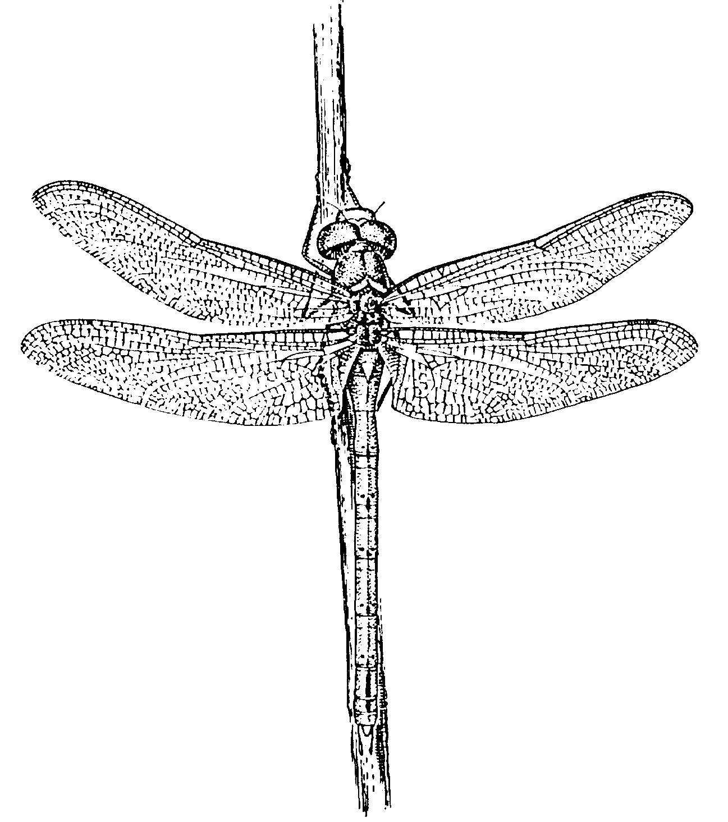

Norfolk Hawker
Intensification of agriculture and arable farming encouraged deep drainage which has led to acid sulphate soils, peat shrinkage, changes in soil structure and sward types and probably changes in the whole soil invertebrate community. Since the mid 1980s the Broads Grazing Marshes Conservation Scheme and the later Environmentally Sensitive Area have reversed this trend of agricultural intensification, preventing further damage to the drained marshes by providing incentives for grassland management, higher water levels and reduced fertiliser usage. As yet there has not been the wide scale improvement in wildlife hoped for, indeed recent studies indicate that the decline is continuing, possibly for reasons other than land management. It is clear that a more extensive agriculture regime and higher water table are critical to the maintenance and enhancement of wildlife interests on the drained marshes. However other factors, often from outside the catchment, also have a significant influence and these appear in some cases now be the limiting factors. Despite the serious decline of nature conservation interests on the drained marshes, they still represent an outstanding wildlife resource.

3 Present wildlife values
The Broads Drained Marshes represent a considerable wildlife resource supporting internationally important populations of wintering waterfowl and raptors, internationally important aquatic plant and wet woodland communities, in addition to nationally important populations of breeding waders and waterfowl and other plant and invertebrate communities.

Wintering waterfowl
In winter, the drained marshes of the Broads Natural Area support internationally and nationally important populations of 10 species of waterfowl (Table 1), two of which are on Annex 1 of the EC Birds Directive – Bewick’s swan and whooper swan. The drained marshlands of the Broads are poorly covered by the Wetland Bird Survey (WeBS). A wintering waterfowl survey of the Broads ESA carried out over the winter of 1996/97 is the most accurate and up to date population estimate of the waterfowl populations within the drained marshes.
Table 1: Wintering wildfowl populations of national (*) and international (**) importance in the drained marshes (national and international qualifying levels derived by WeBS).
Species | Population size | Year(s) | Data source
Mute swan* | 1,562 | 1996/97 | Broads ESA Wintering Waterfowl Survey
Bewick’s swan** | 650 | 1994/95 – 1998/99 | WeBS
Whooper swan* | 109 | 1996/97 | Broads ESA Wintering Waterfowl Survey
Bean goose* | 280 | 1994/95 – 1998/99 | WeBS
Pink-footed goose** | 15,500 | 1997/98 | WeBS
European white-fronted goose* | 818 | 1994/95 – 1998/99 | WeBS
Wigeon ** | 13,953 | 1994/95 – 1998/99 | WeBS
Gadwall* | 71 | 1996/97 | Broads ESA Wintering Waterfowl Survey
Shoveler* | 189 | 1996/97 | Broads ESA Wintering Waterfowl Survey
Golden plover* | 5,024 | 1996/97 | Broads ESA Wintering Waterfowl Survey
Lapwing** | 24,723 | 1996/97 | Broads ESA Wintering Waterfowl Survey
Ruff* | 26 | 1994/95 – 1998/99 | WeBS

3.1.1 Internationally important populations
The Broads Natural Area supports internationally important numbers of Bewick’s swan, representing 7.1% of the British and 2.9% of the north-west European population. They feed mainly on grazing marshes and arable fields in the Bure and Thurne valleys, with some birds moving between the two valleys during the winter. The Broads Natural Area also supports internationally important numbers of wigeon centred on two main sites – Buckenham & Cantley Marshes and Berney Marshes/Breydon Water. A regular wintering population of pink-footed goose has recently become established in the Broads and now reaches internationally important numbers (10,000 at Heigham Holmes and 5,500 at Berney Marshes/Breydon Water in February 1998).
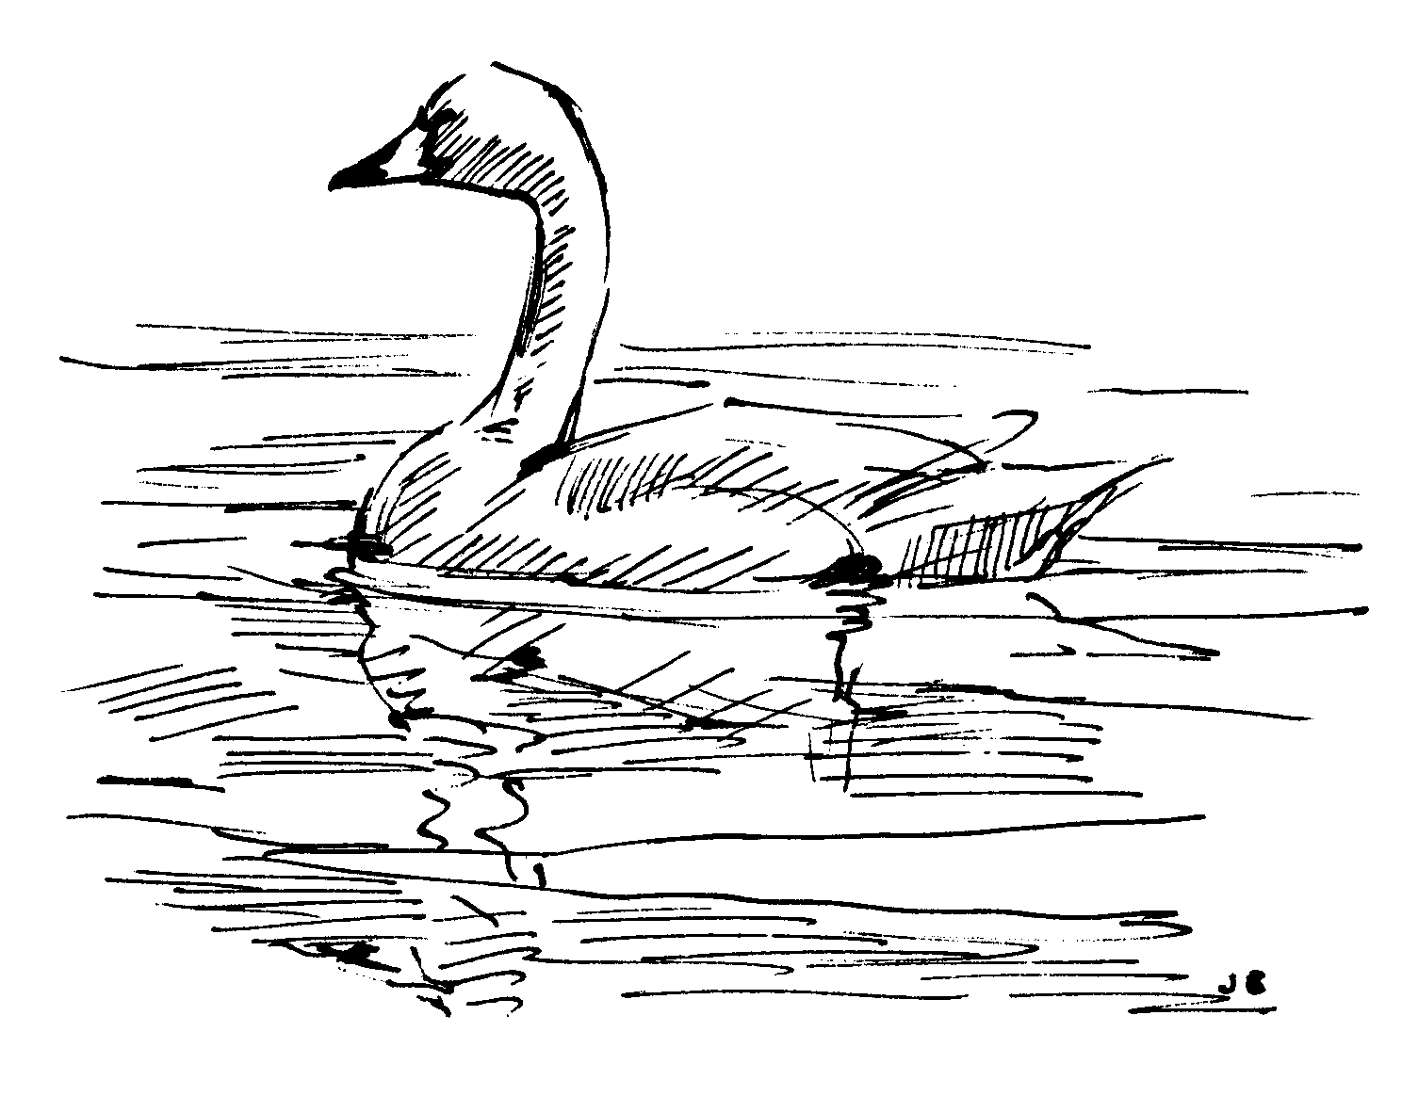

Bewick’s swan

In addition, internationally important numbers of shoveler and lapwing are present within the Broads Natural Area but only partially dependent upon the drained marshes.

3.1.2 Nationally important populations
Nationally important numbers of whooper swan are found feeding largely on arable fields within the upper Thurne valley. This population occasionally reaches internationally important levels. Bean goose and European white-fronted goose also winter in nationally important numbers. Mute swan, teal, gadwall, ruff and golden plover are all present in nationally important numbers but not entirely dependent upon the drained marshes.

3.2 Ditch flora
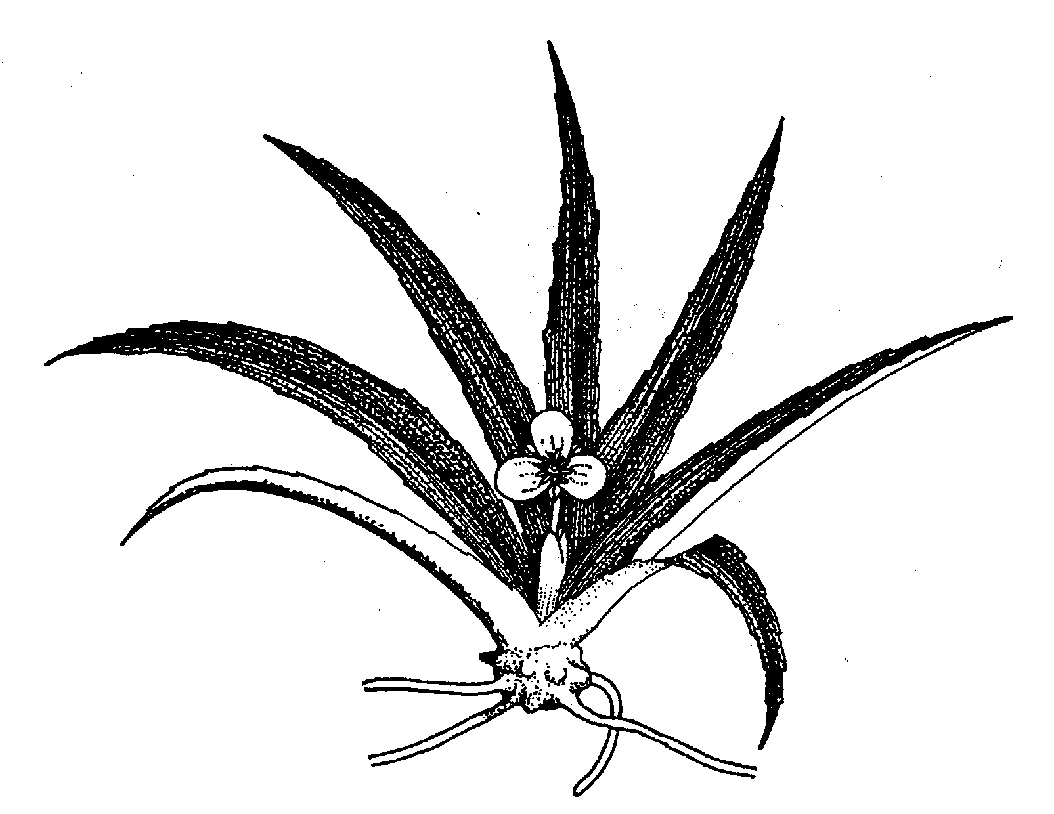

Water soldier
The drained marshes possess a ditch network of outstanding importance for nature conservation, acting as a ‘reservoir’ for some of the plant and animal species lost from the broads themselves. Over 80 per cent of the grazing marsh area possesses ditch types of at least national importance. The freshwater types rich in pondweeds (endgroups A1 – A5a) are recognised as being of international importance. The Broads are notable for the wide range of community types, including an acid and base-rich mesotrophic communities (endgroups A1 & A2), meso-eutrophic communities (endgroups A3a & A3b), freshwater eutrophic types (endgroups A4, A5a, A5b & A6) and algal/brackish communities (endgroups A7a & A7b). The Broadland dyke aquatic endgroup classifications are defined in Appendix 1.

3.3 Plant communities
The majority of the drained marshland area is of limited botanical interest. The main features of conservation value being the small fragments of remaining fen meadow, wet heath, upper saltmarsh and certain acid and mesotrophic grassland communities.

Three fen meadow communities are recognised as being of international and national importance; black bog-rush – blunt-flowered rush Schoenus nigricans-Juncus subnodulosus mire (M13) is confined to just a few small sites. The blunt-flowered rush – marsh thistle Juncus subnodulosus-Cirsium palustre (M22c and M22d) and the purple moor-grass – meadow thistle Molinia caerulea-Cirsium dissectum (M24) fen meadow communities are more widely distributed with fragmented examples in all the river valleys.

The botanically important cross-leaved heath – bog moss Erica tetralix-Sphagnum compactum (M16) wet heath is very limited in extent, the best examples being Potter Heigham fen and the dune slacks behind Winterton dunes. The upper saltmarsh community of interest most frequently encountered is typified by red fescue Festuca rubra (SM16), this is restricted to the marshes adjacent to Breydon Water. The acid grassland characterised by sheep’s fescue – common bent-grass and sheep’s sorrel Festuca ovina-Agrostis capillaris-Rumex acetosella (U1) is present in the Upper Thurne area particularly around Calthorpe Broad. This community is recognised as being of high botanical interest. Two further mesotrophic grassland communities of high botanical interest are present as small fragmentary stands scattered throughout the drained marshes. The crested dog’s-tail grass – marsh marigold Cynosurus cristatus-Caltha palustris (MG8) community is found in association with fen meadow communities, while the fiorin – marsh foxtail Agrostis stolonifera-Alopecurus geniculatus (MG13) community is commonly found in foot drains and periodically inundated areas.

The drained marshes also support stands of wet woodland, most of which is located along the marsh margin. The majority of woodland is dominated by alder Alnus glutinosa, (W6 and W7) and these communities are recognised as being of international and national importance within the Broads. The nationally important grey sallow-downy birch-reed Salix cinerea-Betula pubescens-Phragmites australis (W2) woodland is also present as small stands. All three woodland types have been identified as priority habitats in the UK Biodiversity Action Plan.
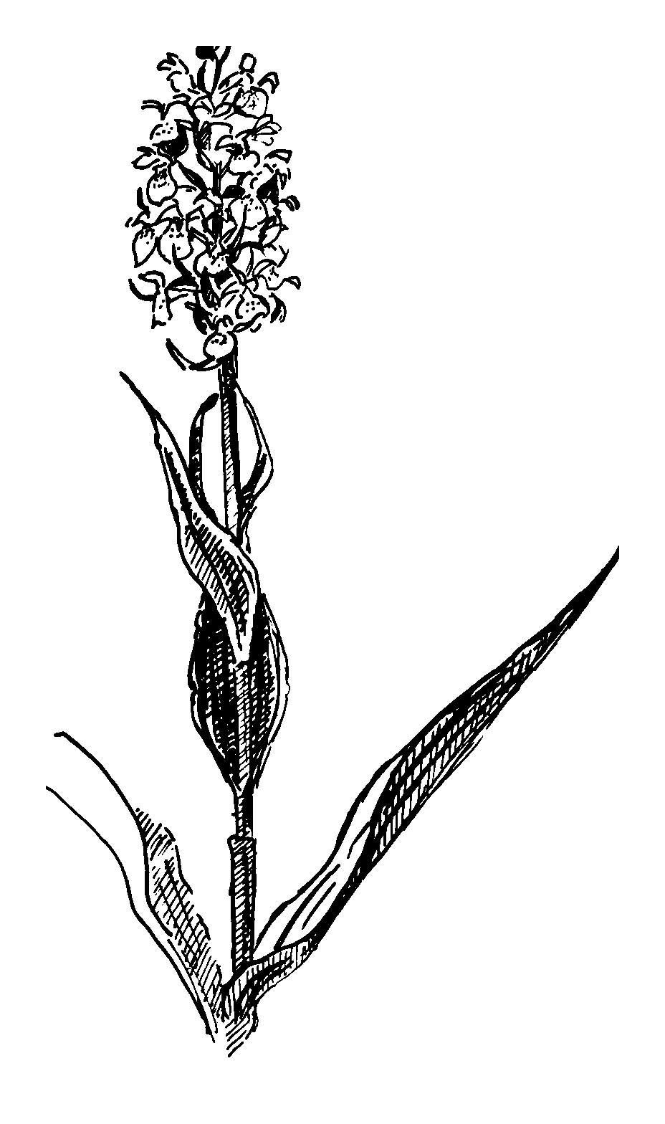

Marsh orchid

3.4 Plant species
The drained marshes support a large number of nationally rare and scarce plants. The ditch system alone supports populations of 108 species of submerged, floating leaved or emergent plants, one of which is nationally rare, while a further 11 are nationally scarce. These are; sharp-leaved pondweed Potamogeton acutifolius, rough stonewort Chara aspera, floating water-plantain Luronium natans (also a UK BAP Priority Species), whorled water milfoil Myriophyllum verticillatum, fen pondweed Potamogeton coloratus, grass-wrack pondweed Potamogeton compressus (also a UK BAP Priority Species), hairlike pondweed Potamogeton trichoides, the liverwort Ricciocarpus natans, spiral tasselweed Ruppia cirrhosa, greater water parsnip Sium latifolium (also a UK BAP Priority Species), water soldier, Stratiotes aloides and clustered stonewort Tolypella glomerata.

The river wall and embankments support populations of one nationally rare and seven nationally scarce species. These are least lettuce Lactuca saligna, bulbous foxtail Alopecurus bulbosus, marsh mallow Althaea officinalis, sea barley Hordeum marinum, dittander Lepidium latifolium, stiff salt-marsh grass Puccinellia rupestris, Borrer’s salt-marsh grass Puccinellia fasiculata and marsh sow-thistle Sonchus palustris.

The brackish grassland communities support four nationally scarce plant species: bulbous foxtail Alopecurus bulbosus; slender hare’s ear Bupleurum tenuissimum; divided sedge Carex divisa and stiff salt-marsh grass Puccinellia rupestris.

The remnants of fen meadow communities, although small in extent, support important populations of six nationally scarce plant species: fibrous tussock sedge Carex appropinquata; narrow-leaved marsh-orchid Dactylorhiza traunsteineri; marsh pea Lathyrus palustris; round-leaved wintergreen Pyrola rotundifolia; greater water parsnip Sium latifolium and the marsh fern Thelypteris palustre.
Table 2: Nationally rare and scarce plant species found in the Broad drained marshes
Species | Conservation Status | Habitat
Floating water-plantain Luronium natans | BAP Priority species | Dykes
greater water parsnip Sium latifolium | BAP Priority species | Dykes, Fen meadow remnants
sharp-leaved pondweed Potamogeton acutifolius | Nationally Rare | Dykes
grass-wrack pondweed Potamogeton compressus | Nationally Scarce | Dykes
Bulbous foxtail Alopecurus bulbosus | Nationally Scarce | River walls/flood embankments, Brackish grazing marshes
marsh mallow Althaea officinalis | Nationally Scarce | River walls/flood embankments
slender hare’s ear Bupleurum tenuissimum | Nationally Scarce | Brackish grazing marshes
fibrous tussock sedge Carex appropinquata | Nationally Scarce | Fen meadow remnants
divided sedge Carex divisa | Nationally Scarce | Brackish grazing marshes
Chara aspera | Nationally Scarce | Dykes
narrow-leaved marsh-orchid Dactylorhiza traunsteineri | Nationally Scarce | Fen meadow remnants
sea barley Hordeum marinum | Nationally Scarce | River walls/flood embankments
marsh pea Lathyrus palustris | Nationally Scarce | Fen meadow remnants
dittander Lepidium latifolium | Nationally Scarce | River walls/flood embankments
whorled water milfoil Myriophyllum verticillatum | Nationally Scarce | Dykes
fen pondweed Potamogeton coloratus | Nationally Scarce | Dykes
hairlike pondweed Potamogeton trichoides | Nationally Scarce | Dykes
stiff salt-marsh grass Puccinellia rupestris | Nationally Scarce | River walls/flood embankments, Brackish grazing marshes
Ricciocarpus natans | Nationally Scarce | Dykes
spiral tasselweed Ruppia cirrhosa | Nationally Scarce | Dykes
marsh sow thistle Sonchus palustris | Nationally Scarce | River walls/flood embankments, Dyke edges
water soldier Stratiotes aloides | Nationally Scarce | Dykes
marsh fern Thelypteris palustre | Nationally Scarce | Fen meadow remnants
Tolypella glomerata |  | Dykes

3.5 Invertebrate communities and species
The drained marshes support about 180 nationally rare or scarce species, 27 of which are characteristic of the Broads grazing marshes. Of these species, six are UK BAP Priority Species while a further 16 are Species of Conservation Concern. Ten more species qualify for but were not included within published national biodiversity lists.
Table 3: Priority invertebrate species found in the Broads drained marshes
Priority species (UK BAP) | Species of conservation concern (UK BAP) | Species of potential concern
Anisus vorticulus | Aeshna isosceles | Anasimyia interpuncta
Donacia aquatica | Ashfordia granulata | Coleophora hydrolapathella
Dromius sigma | Erioptera bivittata | Helochares obscurus
Segmentina nitida | Lejops vittata | Monochroa arundinetella
Vertigo angustior | Cossus cossus | Monochroa conspersella
Vertigo moulinsiana | Hydrophilus piceus | Opostega auritella
 | Libellula fulva | Passaloecus clypealis
 | Nanogona polydesmoides | Psacadina vittigera
 | Odontomyia angulata | Sciomyza dryomyzina
 | Odontomyia ornata | Vidalia cornuta
 | Odynerus simillimus
 | Oxyloma sarsi
 | Pisidium pseudosphaerium
 | Polydesmus gallicus
 | Spilosoma urticae

The ditch systems within the grazing marsh areas are of outstanding invertebrate interest with over 40 different invertebrate species having been recorded from some ditches. The range of habitat, from acidic to base rich and fresh to brackish, adds extra diversity to the species and communities present. The grazing marsh ditches of the Waveney Valley are of particular importance due to the presence of what are probably the highest concentrations nationally of the shiny ramshorn snail Segmentina nitida and the snail Anisus vorticulus, both UK BAP priority species.
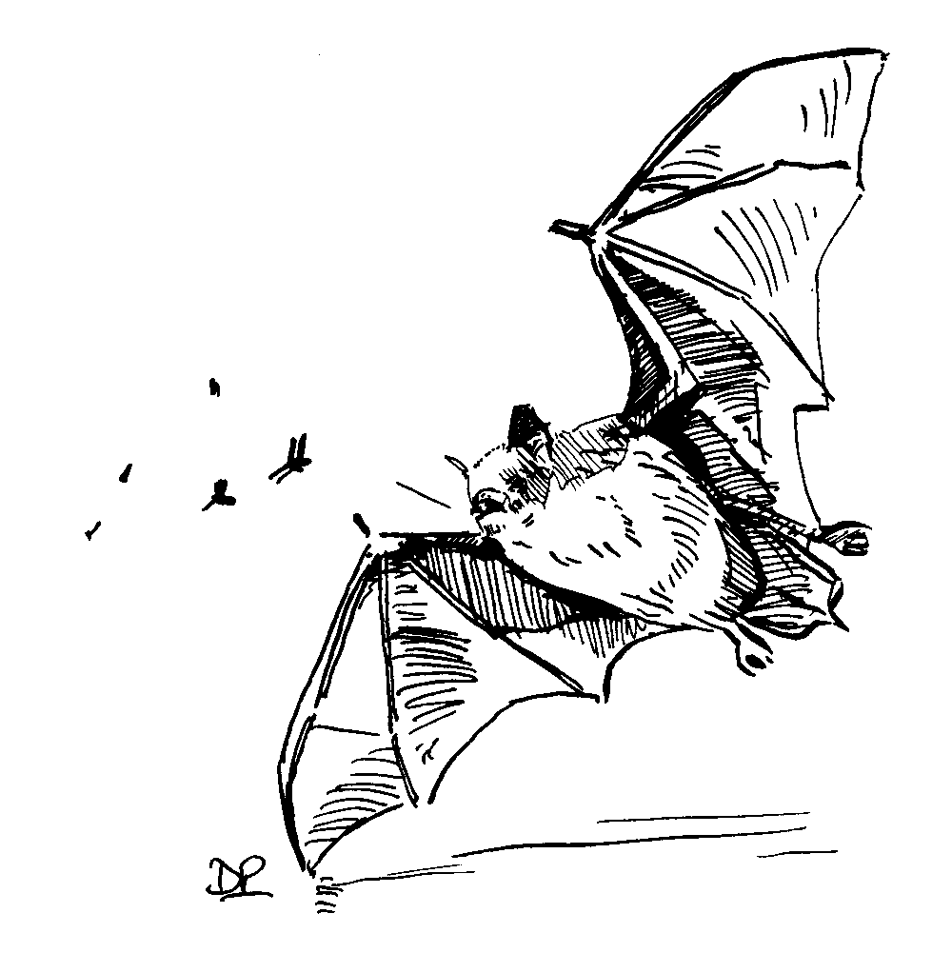

Daubenton’s Bat

3.6 Vertebrates (excluding birds)
The drained marshes remain a key stronghold for the water vole Arvicola terrestris, a UK BAP Priority Species. During the 1997 Broads Dyke Survey, water vole presence was recorded on 8.7% of dyke sections surveyed.

Otters are also increasingly found in the drained marshes as they spread in from the main river corridors.

Several rare species of bat listed under Schedule 5 of the Wildlife and Countryside Act may be found feeding over the margins of this open habitat – the whiskered bat Myotis mystacinus, Natterer’s bat Myotis nattereri, Daubenton’s bat Myotis daubentoni, noctule Nyctalus noctula, pipistrelle Pipistrellus pipistrellus, barbastelle Barbastella barbastellus (also a BAP Priority Species) and brown long-eared bat Plecotus auritus.

The grazing marshes support the most common of the Schedule 5 amphibian species the smooth and palmate newt Triturus vulgaris and Triturus helvaticus, although the latter is locally rare, and the common frog and toad Rana temporaria and Bufo bufo. The grass snake Natrix natrix which is relatively aquatic is the most frequently encountered reptile, although in some areas the adder Vipera berus can be locally common.

3.7 Breeding wildfowl
Pochard, garganey, gadwall and shoveler all breed in the Broads in nationally important concentrations, representing 22%, 10%, 5.3% and 4.5% of the British breeding population respectively. Garganey are mostly restricted to the drained marshes, whereas the other three species breed in a range of wetland habitats.

3.8 Breeding waders
The drained marshes also support substantial but low density populations of breeding waders, notably lapwing, snipe, oystercatcher and redshank. However numbers of breeding waders are well below potential, especially away from nature reserves. A survey of the Broads ESA in 1995 revealed only 1,129 pairs of waders breeding within the Broads Natural Area (Weaver 1995). Between the years 1988 and 1995 on sample grassland sites in the Broads, breeding snipe populations had declined by 40% and lapwing by 14%, redshank numbers remained stable and oystercatcher numbers increased by 37%.

4 Key issues and threats

4.1 Nutrient enrichment / saline intrusion
The intrusion of nutrient enriched or saline water via leaky flood embankments, into freshwater ditches is having an adverse effect upon nationally and internationally important ditch assemblages. Although much has been done in recent years in northern Broadland to improve water quality from polluting point sources, many are still in existence. Several small sewage works discharge their effluent directly in the drained marshes and rely upon the drainage system and pumps to evacuate it to the river. This problem is widespread, affecting a number of important sites. Farm pollution continues to be an issue. Obvious pollution sources have been cleaned up through the co-ordinated efforts of the Environment Agency and DEFRA, however diffuse agricultural runoff continues to be a problem in some areas. In a few sites local water quality problems are associated with old disused waste tips and industrial sites such as those around Great Yarmouth.

4.2 Availability of water
Concentrations of freshwater ditch communities are nearly always associated with the upland marsh margin where freshwater from the catchment, in the form of surface seepage and groundwater supply enters the drained marshes. Ditches adjacent to river walls receive much of their water from river bank seepage. Reduction of the freshwater inputs into the marshes can alter the balance in water quality and lead to loss and damage to freshwater habitats. Reduction of freshwater input also reduces the need to pump, consequently less flushing of the ditch system takes place and stagnation of the freshwater becomes more likely. Improvements to the flood embankments, particularly bank strengthening works, will produce a great reduction in seepage. The potential impact of this in terms of the quantity of water entering the marsh is as yet unknown.
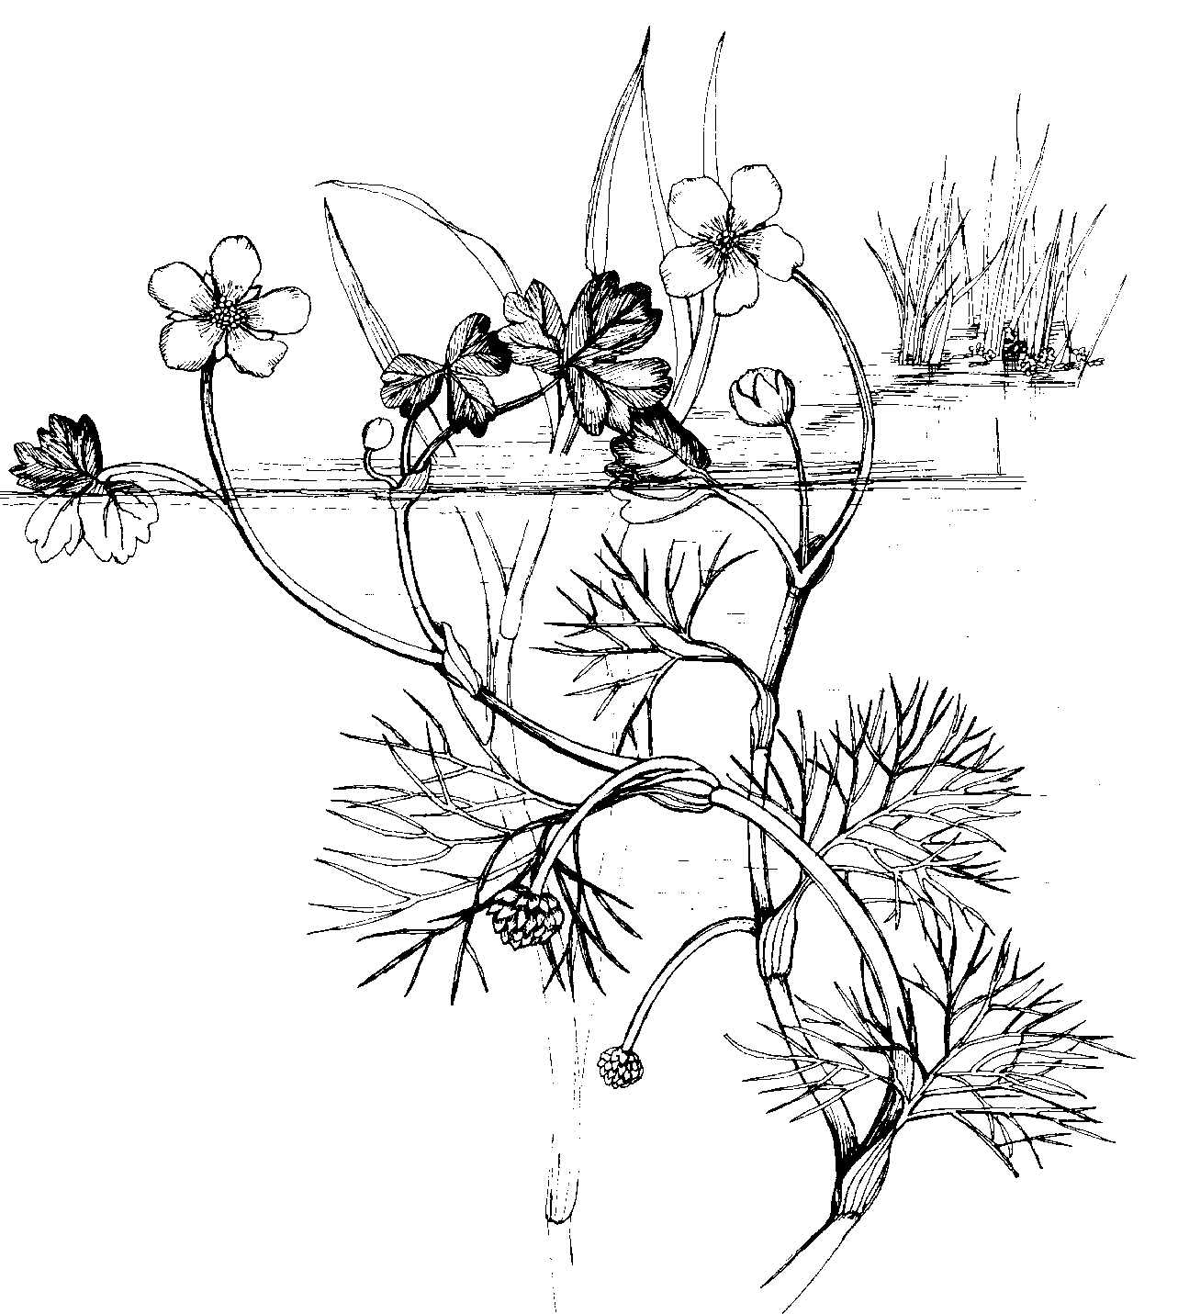

Water crowfoot
On some marshes, the lack of freshwater already requires river water to be deliberately let back into the drained marshland during the summer. Due to nutrient enrichment and increased saline incursion farther up the lower reaches of the rivers, letting river water onto the marshes can lead to a general degradation of their conservation interest and also prove detrimental to grazing animals. This can be a particular problem in the summer when water demand on the marsh is highest and freshwater flows down the rivers are lowest.

4.3 Flood defence
The majority of the drained marshes lie at or below sea level. Appropriate standards of flood defence are necessary both to sustain and develop the nature conservation and agricultural objectives within areas of drained marshland. In the short to medium term the Environmental Agency’s Flood Alleviation Strategy will bring about a programme of works that will secure valued freshwater habitats within the drained marshes. It will also examine opportunities for managed retreat, washlands and set back. Even within this time frame it is expected that some areas will be removed from drained marshland and be returned to the natural river system. As sea levels rise over time a greater proportion of the drained marshes should be allowed to function more naturally as wetland. The way in which this trend may be managed, the extent of such changes and the timescale requires further consideration and integration of national policy (flood defence, nature conservation, land use planning).

The input of eutrophic or brackish water into the drained marshes via leaky flood defence is responsible for loss and damage to freshwater aquatic habitats. Improvements to the flood embankments would reduce the inputs of poor quality water and in turn lead to an expansion of valued freshwater communities. In areas of brackish ditch habitat, many of which are of national importance for nature conservation, embankment improvements and the consequent reduction in saline influence will damage or destroy this feature. Further upstream where the grazing marshes support ditches containing freshwater mesotrophic and meso-eutrophic communities, isolation from eutrophic riverine influences is usually vital in maintaining their integrity.

The Broadland Flood Alleviation Strategy and the associated massive earthworks will also have a major impact upon the ecology of the river walls and embankments. Although many efforts are being taken to undertake the works sensitively, some loss and damage to wildlife interests are inevitable.

Flood defence works, navigation dredging, low summer flows resulting from water abstraction, drought and relative sea level rise has resulted in the migration of the saline limit further up the river system. Insufficient freshwater availability from the marsh margin during the summer and lack of water conservation measures have resulted in owners/IDBs increasingly having to let river water back into the marshes to maintain ditch levels. Over time as rivers become more saline this may not always prove a viable method of providing water of adequate quality. If grazing agriculture, and indeed some of the important conservation features of the drained marshes, are to be sustained then alternative sources of water must be secured, possibly by a combination of winter storage and more efficient distribution systems.

4.4 Water management
The water management system within most marsh levels has evolved over a long period to take into account changes in agricultural practice. Many marshland blocks now contain a number of land uses including grazing marsh, arable and developed areas, each with its own drainage objectives.

Water level management of the drained marshes is achieved by a mixture of structures under the control of both Internal Drainage Boards and independent land owners and occupiers. There is a clear need to re-examine and further research the water requirements for the drainage levels overall and rationalise the management systems in order to increase their effectiveness to meet all objectives, including those of wildlife.

Within the Broads, Water Level Management Plans (WLMPs) are formal agreements over water management. These are prepared on a whole IDB district basis and will cover the entire Broads area. These plans also fulfil the Broads Authority’s requirements under the Norfolk and Suffolk Broads Act 1988, Schedule 3 (33) and DEFRA high level targets. The majority of plans will be produced by Internal Drainage Boards with some minor input from the Environment Agency. DEFRA has the overall responsibility to monitor the process.

The plans intend to balance and integrate the water management needs of different interests, including agriculture, flood defence and conservation. Where agreement is not possible, any differences should be identified. Although the plans are prepared by Operating Authorities, they are agreed with both the Broads Authority and English Nature. Plans are however consulted upon widely and recognise and incorporate the wishes of other interests, including private landowners. Water Level Management Plans to date have been critical in defining the starting management condition, establishing essential communication and identifying the need for modification and improvement to drainage infrastructure. Capital costs for implementing actions identified in WLMPs attract up to 50% funding from DEFRA and some plans have already brought about modification of drainage systems and operations with associated benefits to wildlife. Over time, and with regular review, management systems will be put in place that meet the objectives of all parties and optimise the benefits for wildlife.

4.5 Agricultural practices
Agricultural practices largely determine the water level management regimes adopted in the drained marshes and the way in which the grassland is managed.

Arable farming and intensive grass production requires deep drainage.

When peaty type soils, which contain iron sulphide, are drained for the first time, the soil becomes acid. Iron can be mobilized within the soil profile and this, coupled with iron depositing bacteria, leads to the bright orange-red granular ochre deposit, or the oily sheen seen on ditch water surface. Ochre is toxic to aquatic invertebrates and shades out aquatic plants. This effect is not confined to arable land as ochre can impact upon the dyke system in neighbouring land.

With deep drainage of clays and silty clays which were deposited under the influence of salt water as in a saltmarsh, a soil problem of deflocculation can occur. Normally, with sufficient calcium within the profile, soil stability is maintained. However, following drainage, this calcium can be leached out and replaced by sodium ions which can cause the soil to slump and become unstable.

The Common Agricultural Policy (CAP) has encouraged intensification of farming practices and some grazing marshes are intensively managed for silage and dairy regimes. Incentives under the CAP in the 1960s and 70s encouraged the infilling of ditches and foot-drains and the ‘improvement’ of the grass sward. Today agri-environment schemes, such as the Broads ESA, provide financial incentives to landowners to restore these features and manage the marshes in a way more favourable to wildlife and traditional landscapes.

The Broads Environmentally Sensitive Areas (ESA) Scheme enables landowners to enter their grassland into one of three tiers, each of which has prescriptions for water level height, fertiliser and herbicide applications and grazing intensity. Arable land can be entered into a fourth tier – reversion to permanent grassland. ESA Tier 1 has the most flexible management prescriptions and the lowest payment levels and is designed to protect traditional landscapes by encouraging the retention of grazing marsh. ESA Tier 3 and Tier 2 with water level supplement are the wettest of the tiers available, with higher water level management and offer the highest payment levels. These tiers also deliver the most benefits to nature conservation. However, uptake of the wettest tiers has been lower due to the constraints on timing of grazing imposed by the prescriptions, in some cases insufficient water naturally available to meet the prescription requirements and in other cases, land levels preclude entry into higher tiers.

The ESA Scheme has reversed the trend of agricultural intensification and arable conversion and has begun the process of reverting arable land back to grassland. However, large areas of land remain as arable. This appears to be for two main reasons: firstly many arable farmers manage solely arable enterprises and hence are unable to build in grazing management into their business; secondly some see payments under the ESA scheme are as not attractive enough to encourage the arable reversion to grassland when compared with returns from arable farming and are unwilling to change when there is such an uncertain future in the industry.

The economic crisis that has hit the livestock and milk industry also poses a threat the Broads Drained Marshes. A prolonged depression in market prices for livestock could potentially force a large number of graziers out of business leading to an excess of grazing land. Whilst some of the more intensively grazed land may benefit from lower stocking rates, some grassland will be undergrazed and alternative management methods may be needed which will undoubtedly result in changes to the traditional grazing marsh wildlife.

Methods of ditch maintenance have changed significantly during this century. Modern machines are more efficient than the traditional weed cutting methods, and because of their speed and the cost-benefit of systematic ditch clearance programme, ditches can be maintained more intensively. The combination of frequency and intensity of clearance has resulted in changes in plant communities and the local extinction of some species of ditch plants. However, the opposite can also be true with neglect also causing a decline in ditch interest. Ditch maintenance operations can also impact upon rare invertebrates. In recent years progress has been made in encouraging the restoration of neglected ditches and the undertaking of maintenance work with greater sensitivity to wildlife.

Wildlife thrives under a non-intensive grazing regime with a high water table throughout the year. Where traditional grazing is practised, water levels are usually maintained at a level to maximise agricultural productivity rather than to achieve maximum conservation benefit. However a number of farming enterprises on both clay and peat soils have demonstrated the way agricultural and nature conservation objectives can be mutually achieved. However the management of land for dual objectives is not widespread, and there is a general reticence to undertake additional necessary works to achieve conservation goals or to have generally higher water levels, as despite new efficient pumps, there is still a fear of flooding.

4.6 Human impacts
Disturbance to wintering bird populations is known to be a significant issue in a few important sites. The majority of the problems have arisen from wildfowling taking place close to large concentrations of birds, such as those in the mid-Yare valley. At present the pattern of shooting is unknown, so to is its significance.

Land take by roads, industrial and recreational development, residential and agricultural dwellings and land raising continues to be a threat. The policies of the Broads Plan and Broads Local Plan have reduced much of this threat within the Authority’s area, however around Great Yarmouth development on the drained marshes is seen as the solution to a lack of industrial land.

4.7 Introduction of alien/non-native species
The introduction of alien or non-native species is a potential serious threat to the conservation status of some features of the drained marshes.
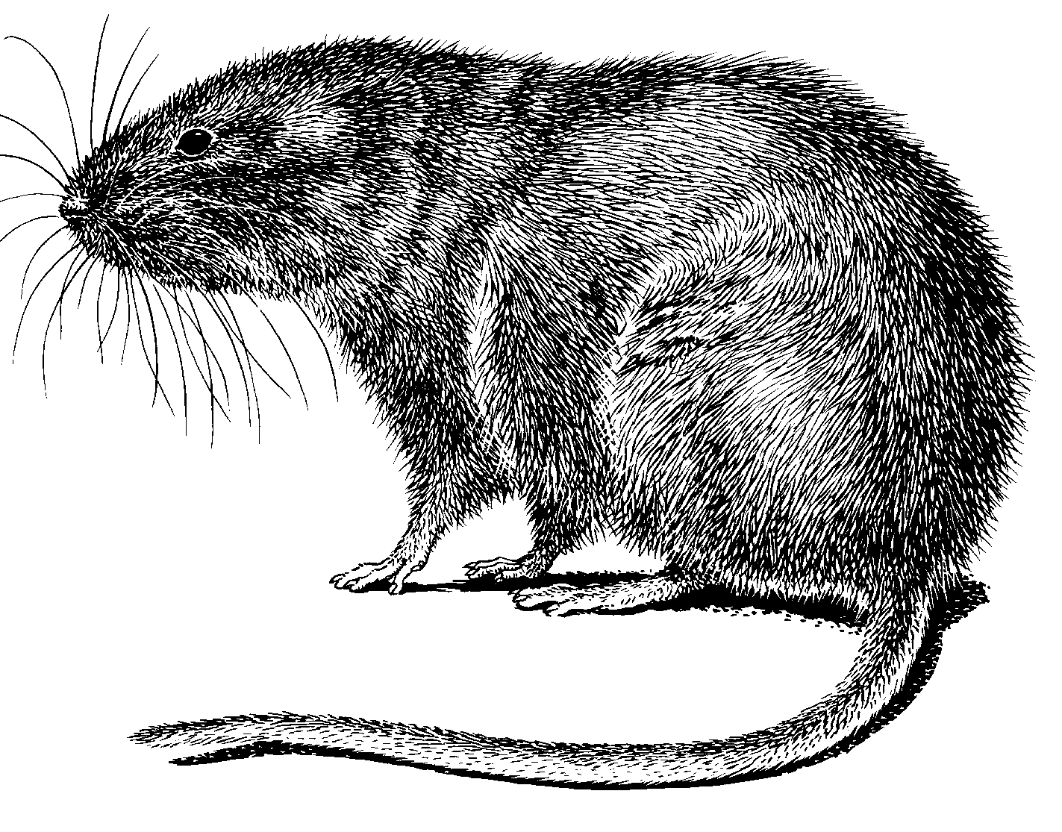

Water vole

Three invasive aquatic plant species, commonly sold in garden centres, have already been recorded within the Broads – Australian stonecrop Crassula helmsii, water fern Azolla filiculoides and parrot’s feather Myriophyllum aquaticum. A number of other problem species eg floating pennywort Hydrocotolye ranunculoides have not yet been recorded from the Broads but are readily available from garden centres. All these species could have a serious impact upon the nationally and internationally important dyke communities in the drained marshes.

Mink are widespread throughout the Broads but in low densities. Mink predation, in combination with other factors such as disturbance and bank erosion, has been implicated in the decline of the water vole Aricola terrestris within the Broads. Mink do not appear to have a negative impact on otter populations.

4.8 Lack of detailed vision
The Broads Natural Area Profile recognised that Broadland’s environment has changed significantly over the past 700 years. With rising sea levels the Broads will continue to change and there are a number of choices that can be made, each with its own advantages and disadvantages, for various nature conservation interests. The preferred option promoted by conservation interests is to develop a more naturally functioning wetland environment as opposed to try to maintain the status quo. However, we are not at present able to answer how and over what timescale changes in the Broads might best be managed. We are however able to develop a common wildlife, and hopefully wildlife/landscape view, of how we value individual areas of floodplain and allocate priority ratings for the potential range of habitats and management regimes they might fulfil in the future.

5 Nature conservation vision for the drained marshes

A complex network of brimming full ditches dissects the expansive grazing marsh which stretches to the wooded horizon, the flatness is occasionally broken up by wooden gateways, reed-fringed trackways and flood embankments. The ditches are rich with aquatic plants such as water soldier and frogbit and are home to a dazzling array of dragonflies and winged insects that flit across the marshes. Grazing animals drink from the ditch edges, trampling the tall stands of emergent plants at the water margin. The cries of waders and drumming snipe echo across this open landscape. Fen meadows rich in flowers produce a colourful display on the peaty soils along the marsh margins. Where wintry waters over-top their banks and form pools of standing water, flocks of wildfowl and herds of Bewick’s swans settle noisily. Progressively there will be a subtle change in the mosaic of vegetation as the tidal influence on drained marshes becomes stronger, as a consequence of the increasing height of relative sea level. Swards rich in salt-tolerant grasses form a tussocked landscape in the lower reaches of the rivers. Saltmarsh plants fringe the water’s edge and stretch landward in the lower river valleys where washlands, inundated with stormy waters, are formed.

Lapwing

Objectives

Overall aim
To maintain and enhance the important nature conservation features of the Broads drained marshes

International objectives

1 Internationally important wintering waterfowl populations

Current status
The status of internationally important waterfowl populations on the Broads drained marshes are difficult to quantify as regular, organised counts are only carried out on a few key sites. Using data from a variety of sources, the Broads drained marshes supports internationally important wintering populations of Bewick’s swans (mean peak count of 694 between 1992/93 and 1996/97 confined to two sites), pink-footed goose (up to 7,000 centred around one site), wigeon (15,755 in 1996/97), gadwall (301 in 1996/97), shoveler (433 in 1996/97) and lapwing (25,723 in 1996/97). Of these, Bewick’s swan, pink-footed goose and wigeon are dependent upon the drained marshes. The remaining three species are only partially dependant upon the drained marshes and will use other wetland habitats.

Maps 1–5 show the distribution of Bewick’s swan, pink-footed goose, wigeon, shoveler and lapwing respectively in the drained marshes for the 1996/97 winter.

Objective
Maintain numbers and distribution of internationally important wintering waterfowl populations currently using the Broads drained marshes and enhance habitat in protected areas which are currently failing to meet full potential.

Action | Lead agencies | Mechanisms
- Define European objectives and monitor | EN | SPA/SAC Conservation Objectives
- Ensure Broads ESA provides appropriate extent and quality of wet grassland habitats | DEFRA | Broads ESA
- Ensure that wintering wildfowl numbers are not adversely affected by disturbance from visitor pressure or wildfowling activity | RSPB, NWT, SWT, NT, EN, BA, BASC/land owners | Reserve management plans, Broads Plan
- Ensure that nature conservation interests are taken into account in decisions over public access to the countryside | DEFRA with input at a national level from conservation organisations, LAs
- Ensure Water Level Management Plans support the delivery of objectives for wintering waterfowl | IDBs, EN | Water Level Management Plans
- Ensure that top sites for wintering waterfowl are surveyed by WeBS | WeBS Partnership (JNCC/RSPB/BTO/WWT) | Monthly WeBS counts over winter period
- Organise a one-off complete waterfowl re-survey of the Broads. | RSPB/BA/EN/DEFRA

Current constraints
- Uptake of ESA tier 3 is low
- Incomplete monitoring of wintering waterfowl in the Broads through WeBS/other surveys
- Disturbance on some sites by wildfowling and other human activities.

Indicators
Drained marshes continue to support internationally important numbers of Bewick’s swan, pink-footed goose, wigeon, gadwall, shoveler and lapwing.

Source of verification
WeBS reports.

2 Fen meadow communities

Current status
Three fen meadow communities are recognised as being of international and national importance in the Broads – NVC communities M13, M22 and M24. The Broads contains 1.4ha, 110ha and 34ha of these habitat types respectively. Although the majority of these fen meadows have been incorporated within the Fen Management Strategy, there is a need to survey and incorporate those that were not. In addition, some areas of what is currently grassland may be suitable for fen meadow restoration, particularly on peat-based soils.

Objective
Improve and restore within the visions and remit of the Fen Management Strategy all remaining areas of fen meadow within the drained marshes and re-create further areas of fen meadow on suitable peat soils.

Actions | Lead agencies | Mechanisms
- Identify fen meadows that were not included within the Fen Resource Survey and use results to inform re-creation target for drained marshes | BA/EN | Fen Management Strategy Review

Actions | Lead agencies | Mechanisms
- Ensure remaining areas of fen meadow are suitably managed | DEFRA | Broads ESA
- Ensure remaining areas of fen meadow receive suitable water management regime | IDBs | WLMPs
- Identify and promote potential sites for fen meadow re-creation | all | Broads ESA, Fen WES, Norfolk BAP, Suffolk BAP, proposed Wetland Lottery Project
- Promote management and restoration of fen meadows | all | Broads ESA, Fen WES, Norfolk BAP, Suffolk BAP, proposed Wetland Lottery Project
- Ensure any areas of fen meadow or potential sites for fen meadow re-creation are incorporated within the Fen Management Strategy | BA, EN | Fen Management Strategy
- Ensure LEAPs incorporate targets for fen meadow re-creation | EA | Broadland Rivers LEAP

Current constraint
- Inappropriate management on privately owned land
- Lack of information on potential areas for fen meadow re-creation
- It may not be possible to recreate calcareous/neutral fen meadows on peat soils that have been drained for prolonged periods
- Water resources may be insufficient in some areas.

Indicators
All remaining fen meadow communities on the drained marshes identified and incorporated into the Fen Management Strategy by 2007.

All areas with potential for fen meadow creation identified by 2007.

Source of verification
Fen Management Strategy review.

3 Internationally important dyke communities

Current status
For distribution of endgroups in 1997 see Map 6. The 1997 dyke survey revealed a net loss of 5% of the high conservation value mesotrophic and meso-eutrophic endgroups (endgroups A1 to A3b) since 1988/89 and an overall loss of 40% of species-rich eutrophic dykes (endgroups A1 to A5a). This was accompanied by an increase of 6% and 25% in the species-poor eutrophic dykes (endgroup A5b) and algal-dominated and brackish dykes (A7a and A7b) respectively.

Objective
Maintain as a minimum the 1997 extent of endgroups A1 – A3b (mesotrophic) and A5a (meso-eutrophic), re-establish the 1988 extent and distribution by 2009 and the 1974 extent and distribution by 2015.

Actions | Lead agencies | Mechanisms
- Ensure ecologically sensitive management prescriptions for dyke maintenance are implemented throughout the Broads where this does not conflict with other statutory obligations | DEFRA, IDBs EA | Broads ESA, WLMPs, Standard Maintenance Operations
- Ensure Broadland Rivers LEAP contains targets for internationally important dyke communities | EA | Broadland Rivers LEAP
- Ensure any new water abstraction licences do not have an adverse impact upon internationally important dyke communities | EA | Abstraction licence consultation process
- Ensure that all existing abstraction licences affecting sites of international importance are reviewed as part of the Review of Consents process | EA | Review of consents process
- Ensure Broads Flood Alleviation Project delivers benefits to dyke system | EA | Broads Flood Alleviation Project
- Ensure WLMPs support the delivery of objectives for internationally important dyke communities | IDB, EN | WLMP consultation process
- Ensure guidelines for sensitive dyke management are distributed to all management agencies and land-owners | EN, DEFRA, IDB | Broads ESA, Water Level Management Plans
- Provide dyke management training opportunities for contractors and land-managers | EN, RSPB, BA | Training days as and when required
- Investigate the impact of agricultural residues upon dyke flora and fauna | EA
- Prevent the establishment of alien aquatic plant species within the system of dykes in the drained marshes | EN/BA
- Investigate further the factors affecting dyke plant communities and particularly the causes of identified detrimental changes | EN/BA | Broads Plan

Current constraints
- Deep drainage
- Inappropriate water management regimes
- Intrusion of nutrient enriched and brackish water through leaky flood embankments and in some areas, sewage treatment works
- Introduction of brackish river water into dyke systems to achieve ESA targets and out of agricultural necessity
- Reduction in freshwater input
- Inappropriate dyke maintenance (both over and under management) and inability to monitor dyke management conditions
- Potential effects of climate change and sea level rise upon dyke systems are unknown and the stated targets may be unrealistic.

Indicators
1988 extent and distribution of endgroups A1 – A3b (mesotrophic) and A5a (meso-eutrophic) re-established by 2009 and 1974 extent and distribution re established by 2015.

Sources of verification
Spot check surveys in 2005, 2009 and 2015.

National objectives

4 Nationally scarce plants/communities

Current status
The Broads drained marshes currently support 24 nationally scarce or RDB plant species and three Nationally Scarce plant communities. Of the plant species, 13 are found in drainage dykes or dyke edges, six on river walls and flood embankments, four on brackish grasslands and five in fen meadow remnants. Five species are found in fewer than three localities in the Broads.

Objectives
Maintain populations of all nationally scarce plant species and vegetation communities (U1, MG8, MG13)..

Restore and recreate nationally scarce plant communities where possible and appropriate.

Actions | Lead agencies | Mechanisms
- Ensure Broads ESA incorporates management prescriptions appropriate for nationally scarce species and vegetation communities | DEFRA, DEFRA, | Broads ESA
- Ensure Broads Flood Alleviation Project takes appropriate measures to protect nationally scarce plant species growing on river walls, in set-back and clay sourcing areas | EA | Site Specific Environmental Assessments
- Ensure guidelines for sensitive dyke management are distributed to all management agencies | EN, DEFRA
- Incorporate conservation objectives for nationally scarce plant communities and species into Broadland Rivers LEAP | EA | Broadland Rivers LEAP
- Identify extent and distribution of nationally scarce vegetation communities through survey | BA, EA, RSPB, NWT, SWT, NT | NVC surveys
- Carry out baseline survey of nationally scarce plant species along river walls | EA | Broads Flood Alleviation Project

Current constraints
- Grassland management inconsistent with the requirements of some nationally scarce plants, eg through over/under grazing, use of chemicals and fertilisers
- Inappropriate dyke maintenance
- Inappropriate water level management.

Indicators
No reduction in number and distribution of nationally scarce plants.

No reduction in area or quality of nationally scarce plant communities.

Sources of verification
Spot checks, Site Specific Environmental Assessments carried out as part of flood alleviation strategy, Fen resource, fen meadow and dyke surveys.

5 Breeding waders

Current status
A survey of breeding waders (lapwing, snipe, redshank and oystercatcher) within the Broads ESA in 1995 revealed a total of 1129 pairs within the Broads Executive Area (Maps 7–10). On sites that were surveyed in 1988, snipe numbers were shown to have declined by 40% and lapwing by 14%. Redshank numbers remained stable and oystercatcher numbers increased by 37%. Grassland entered into ESA Tier 2 held 33–42% of each wader population but at low densities (0.09 prs/ha). Reserves and grassland entered into ESA Tier 3 held the highest densities of breeding waders (0.23 prs/ha and 0.25 prs/ha respectively). ESA Tier 1 grassland was very poor for breeding waders supporting a density of only 0.03 prs/ha.

Objective
Maintain as a minimum the 1995 population size and distribution and aim to reverse decline and restore breeding wader density to at least that of 1982 (0.1 prs/ha overall) by 2010.

Actions | Lead agencies | Mechanisms
- Promote increased uptake of ESA Tier 3 and water level supplements where they will not damage other important conservation features, eg. fen meadows | DEFRA, RSPB, BA | Broads ESA
- Ensure WLMPs support the delivery of objectives for breeding waders | IDB, EN | WLMPs
- Incorporate conservation objectives for breeding waders into Broadland Rivers LEAP | EA | Broadland Rivers LEAP
- Ensure wet grassland reserves and SSSIs are managed optimally for breeding waders where this does not conflict with other conservation objectives of the site | RSPB, NWT, SWT, EN, NT | EN Positive Management Agreements, Reserve Management Plans
- Ensure that nature conservation interests are taken into account in decisions over public access to the countryside | DEFRA with input at a national level from conservation organisations, LAs
- Resurvey breeding wader population within the Broads ESA | RSPB | Breeding Waders of Wet Meadows Survey 2002

Current constraints
- Uptake of ESA tier 3 is low
- Dyke management prescriptions for breeding waders may conflict with those for water vole
- Incomplete understanding of habitat requirements of breeding waders, especially snipe.

Indicators
Average breeding wader density of at least 0.1 pairs/ha over the Broads Executive Area by 2010.

Sources of verification
Reserve annual reports
Broads ESA annual reports
Breeding wader survey results.

6 Breeding wildfowl

Current status
The Broads support nationally important breeding populations of pochard (10% UK breeding population), garganey (10%), gadwall (5%) and shoveler (4.5%). Garganey are mostly confined to the drained marshes whereas the other species breed in a range of other wetland habitats and are only partly dependent upon the drained marshes.

Objectives
Maintain and enhance current nationally important breeding populations of wildfowl.

Actions | Lead agencies | Mechanisms
- Ensure Broads ESA provides appropriate extent and quality of wet grassland habitats during the breeding season | DEFRA | Broads ESA
- Ensure reserves and SSSIs are managed to benefit breeding wildfowl where this does not conflict with other conservation objectives of the site | EN, RSPB, NWT, SWT, NT | EN Positive Management Agreements , Reserve management plans
- Carry out complete survey of breeding waterfowl in the drained marshes | EN, RSPB, BA
- Ensure that nature conservation interests are taken into account in decisions over public access to the countryside | Countryside Agency with input at a national level from conservation organisations, LAs

Current constraints
- Some dyke management operations may be inconsistent with the requirements of breeding waterfowl
- Some water level management regimes may be inconsistent with the requirements of breeding waterfowl
- Incomplete survey coverage.

Indicators
Broads drained marshes continue to support nationally important breeding populations of pochard, garganey, gadwall and shoveler.

Sources of verification
Breeding bird surveys, reserve annual reports.

7 Nationally important wintering wildfowl populations

Current status
The Broads drained marshes support nationally important wintering populations of: mute swan (1,562 in 1996/97), whooper swan (109 in 1996/97), bean goose (310 in 1996/97), white-fronted goose (mean peak count of 805 at three sites between 1992/93 and 1996/97) and golden plover (5,024 in 1997/97).

Maps 11–15 show the distribution of mute swan, whooper swan, bean goose, white-fronted goose and golden plover respectively in the drained marshes for the 1996/97 winter.

Objective
Maintain as a minimum the 1996/97 size and distribution of wildfowl populations of national importance.

Actions | Lead agencies | Mechanisms
- Ensure Broads ESA provides appropriate extent and quality of wet grassland habitats | DEFRA | Broads ESA
- Ensure that wintering wildfowl numbers are not adversely affected by disturbance from visitor pressure or wildfowling activity | RSPB, NWT, SWT, NT, EN, BA, Ramblers groups BASC/land owners | Reserve management plans, Broads Plan
- Ensure that nature conservation interests are taken into account in decisions over public access to the countryside | Countryside Agency with input at a national level from conservation organisations
- Ensure Water Level Management Plans support the delivery of objectives for wintering waterfowl | IDBs, EN, BA | Water Level Management Plans
- Ensure that top sites for wintering waterfowl are covered by WeBS | WeBS Partnership (JNCC/RSPB/BTO/WWT) | Monthly WeBS counts over winter period
- Organise a one-off complete waterfowl survey of the Broads | RSPB/BA

Current constraints
- Uptake of ESA tier 3 is low
- Disturbance on some sites by wildfowling and other human activities
- Inappropriate management of some grassland sites
- Incomplete monitoring of wintering waterfowl in the Broads through WeBS/other surveys.

Indicators
Drained marshes continue to support nationally important numbers of mute swan, whooper swan, bean goose, white-fronted goose and golden plover.

Sources of verification
Annual WeBS reports.

8 Priority invertebrates

Current status
The Broads drained marshes support around 180 nationally rare or scarce invertebrate species. Of these, six are UK BAP priority species and 16 are species of conservation concern. A further 10 species of potential concern were identified in the RSPB Biodiversity Audit (Shardlow et al 1999). These species qualify for but were not included within published national biodiversity lists. A survey carried out in 1997 revealed the River Waveney grazing marshes to be of particular importance for aquatic molluscs (Jackson & Howlett 1999).

Objective
Maintain populations of priority invertebrates within the drained marshes.

Actions | Lead agencies | Mechanisms
- Assess the status of BAP priority species within the drained marshes | EN, BA, RSPB, NWT, SWT, NCC, EA Norfolk Biological Records Centre, Suffolk Biological Records Centre | Norfolk BAP, Suffolk BAP
- Ensure Norfolk and Suffolk SAPs for priority species are implemented within specified time frame | All BAP partners (NCC, SCC, RSPB, NWT, SWT, EA, EN) | Norfolk BAP, Suffolk BAP
- Encourage research, survey and monitoring of Species of Conservation Concern and potential SCC. | EN, BA, RSPB, NWT, SWT, Norfolk Biological Records Centre, Suffolk Biological Records Centre | Norfolk BAP, Suffolk BAP
- Ensure all reserves and SSSIs within drained marshes have and meet management objectives for invertebrate conservation | EN, RSPB, NWT, NT, BA | Reserve Management Plans, EN Positive Management Agreements
- Ensure Broads ESA prescriptions take the needs of priority invertebrates into account | DEFRA | Broads ESA
- Ensure relevant Water Level Management Plans take into account the ecological requirements of these species where known | EA, IDBs, EN | WLMP Consultation Process

Actions | Lead agencies | Mechanisms
- Ensure dyke and flood defence maintenance programmes take the needs of priority invertebrates into account | IBDs, EA, EN, BA, RSPB, NWT, SWT, NT, DEFRA | Reserve management plans, Flood Alleviation Strategy, Broads ESA, WLMPs
- Ensure that management advice is available to managers of land supporting populations of priority invertebrates | EN/BA/DEFRA

Current constraints
- Knowledge of presence & distribution of many species is incomplete
- Ecological requirements of many species is not fully understood so difficult to suggest appropriate ditch management regimes
- Pollution of dykes and saline intrusion
- Drought and overpumping of marshes in some areas.

Indicators
No reduction in number of species and distribution of nationally rare and scarce invertebrates.

Sources of verification
Surveys.

9 Dyke communities of national importance

Current status
As well as the internationally important dyke communities considered by Objective 3, endgroups A4, A5a and A7b are also nationally important. For the distribution of these endgroups in 1997, see map 4.

Objective
In parallel with Objective 3, maintain as a minimum the 1997 extent of endgroups A4, A5a and A7b, re-establish the 1988 extent and distribution by 2009 and the 1974 extent and distribution by 2015.

Actions | Lead agencies | Mechanisms
- Ensure Broads ESA and WLMPs incorporate tighter management prescriptions for dyke maintenance | DEFRA, DEFRA, IDBs | Broads ESA, WLMPs, Standard Maintenance Operations
- Ensure Broadland Rivers LEAP contains targets for nationally important dyke communities | EA | Broadland Rivers LEAP

Actions | Lead agencies | Mechanisms
- Ensure any new water abstraction licences do not have an adverse impact upon nationally important dyke communities | EA | Abstraction licence consultation process
- Ensure Broads Flood Alleviation Project delivers benefits to dyke system | EA | Broads Flood Alleviation Project
- Ensure WLMPs support objectives for nationally important dyke communities | IDB, EN | WLMP consultation process
- Ensure guidelines for sensitive dyke management are distributed to all management agencies | EN, DEFRA, BA, IDB
- Provide dyke management training opportunities for contractors and land-managers | EN, RSPB, BA | Training days as and when required
- Investigate the impact of agricultural residues upon dyke flora and fauna | EA/DEFRA
- Prevent the establishment of alien aquatic plant species within the system of dykes in the drained marshes | EN/BA

Current constraints
- Deep drainage
- Intrusion of nutrient enriched and brackish water through leaky flood embankments and in some areas, from sewage treatment works
- Introduction of river water into dyke systems to achieve ESA targets and out of agricultural necessity
- Reduction in freshwater inputs
- Inappropriate dyke maintenance and inability to monitor dyke management conditions
- Potential effects of climate change and sea level rise upon dyke systems are unknown and the stated targets may be unrealistic.

Indicators
No decline in extent of naturally brackish dyke communities.
Mesotrophic dykes that have been damaged by saline intrusion/ eutrophication since 1998 restored by 2009.

Sources of verification
Spot check surveys in 2005, 2009 and 2015.

10 Water voles and otters

Current status
The 1997 water vole survey identified the dykes of the Broads drained marshes as a key stronghold for water voles in Norfolk. The 1997 Broads Dyke Survey recorded water vole presence on 8.7% of the dyke sections surveyed. Countywide, dykes appeared to be the most favoured habitat type. Population trends in the drained marshes are unknown although it is thought that there has been a slight decline in the county since 1989/90.

Objective
Maintain as a minimum the 1997 distribution of water vole in the drained marshes and aim to restore 1970s range and distribution by 2010.

Actions | Lead agencies | Mechanisms
- Identify, monitor and assess viability of key water vole and otter populations within the drained marshes | NWT, SWT, EA, EN | Specific survey
- Incorporate water vole and otter conservation objectives into LEAPs | EA | Broadland Rivers LEAP
- Seek to include the requirements for water vole and otter into management prescriptions for SSSIs | EN | Management agreements, WES
- Ensure dyke management prescriptions for Broads ESA and WLMPs are of benefit to water vole and otter whilst not conflicting with the needs of other wildlife | DEFRA, IDB, RSPB, EN | Broads ESA review, consultation on WLMPs
- Encourage further uptake of arable grassland margins and arable reversion tiers of Broads ESA | DEFRA | Broads ESA
- Ensure action plans for water vole and otter are implemented within specified time frame | NWT, SWT | Norfolk BAP, Suffolk BAP
- Ensure land owners/managers receive appropriate advice on water vole and otter management | DEFRA, NWT | Water Vole Conservation Handbook
- Ensure no damage to water vole and otter populations and habitat through flood alleviation work | EA | Site specific environmental assessments

Current constraints
- Unsuitable management of dykes and bank side vegetation
- Mink are present within the Broads, and if uncontrolled could potentially lead to local extinctions of water voles
- Dyke management prescriptions for water voles could conflict with management prescriptions for breeding waders/wildfowl (water voles require steep bank profile, breeding waders/wildfowl require shallow bank profile).

Indicators
Completed water vole and otter survey of the Broads drained marshes.

Water vole and otter conservation objectives incorporated into Broadland Rivers LEAP and into WLMPs.

Sources of verification
Broadland Rivers LEAP
WLMPs
another survey.

Biodiversity Action Plan Habitat Re-creation objectives

11 Coastal and floodplain grazing marsh

Current status
There are currently around 17470ha of grassland within the Broads Executive Area. Following its introduction in 1988, the Broads ESA has reversed the loss of grassland in the Broads. However, the ESA could deliver far wider conservation benefits if more land in private ownership could be entered into the higher ESA tiers.

Objective
Maintain as a minimum the current extent and quality of coastal and floodplain grazing marsh and restore and enhance these where they are considered to be unfavourable. Recreate 360ha of new grazing marsh on land currently under arable cultivation and restore 1400ha of existing grazing marsh by 2010.

Actions | Lead agencies | Mechanisms
- Ensure Broads ESA offers attractive and competitive incentives for grazing marsh creation. | DEFRA | Broads ESA
- Ensure payment levels for ESA Tiers that deliver the most conservation benefits are raised relative to other tiers | DEFRA | Broads ESA

Actions | Lead agencies | Mechanisms
- Ensure sufficient water quality and availability for new and existing areas of grazing marsh | EA, BA, IDBs | Broadland Rivers LEAP, WLMPs
- Identify priority areas for the creation of wet grassland | EN, BA, RSPB, EA
- Promote and facilitate the creation of wet grassland on the priority areas identified | EN, BA, RSPB, EA
- Complete the programme of WLMPs for the Broads drained marshes | IDBs
- Ensure flood defence works are carried out in an ecologically sensitive manner | EA | Broads Flood Alleviation Project
- Ensure Broadland Rivers LEAP includes appropriate targets and actions for the creation and restoration of grazing marsh | EA | Broadland Rivers LEAP

Current constraints
- Support systems for reversion of arable land to grassland are sometimes viewed as uncompetitive and do not adequately compensate for the loss of arable production
- Some farmers unwilling to invest in change given the uncertain futures in agriculture
- Downturn in livestock industry could affect stocking densities and availability of livestock
- Payment levels and grazing restrictions on the ESA tiers that deliver most conservation benefit are not competitive relative to other tier prescriptions
- In some areas, water level management constraints prevent some land owners entering their land into higher ESA tiers
- Lack of freshwater within the system.

Indicators
At least 17,500ha of grassland maintained within the Broads Natural Area.At least 360ha of grazing marsh recreated by 2010.
At least 1400ha of existing grazing marsh restored by 2010.

Sources of verification
Broads ESA Annual Review.

12 Reedbed

Current status
The Broads executive area contains 244ha of wet reedbed (defined as S4 NVC communities). All significant areas of reedbed within the drained marshes are covered within the Fen Management Strategy. There is however considerable potential for reedbed creation on land currently of little conservation value within the drained marshes.

Objective
Identify potential new areas for reedbed creation and recreate 400ha of new reedbed in blocks of >20ha on the drained marshes on land currently of low conservation value.

Actions | Lead agencies | Mechanisms
- Ensure Broads ESA offers attractive and competitive incentives for reedbed creation and management. | DEFRA | Broads ESA
- Safeguard water resources for new reedbeds | BA, EA, IDBs | Broadland Rivers LEAP, Flood Alleviation Strategy
- Identify possible areas for reedbed creation within the drained marshes | RSPB, BA, EA, EN | Broadland Rivers LEAP, Flood Alleviation Strategy, Broads ESA
- Promote and facilitate the creation of reedbed on the priority areas identified | All BAP partners | Norfolk BAP, Suffolk BAP

Current constraints
- Financial incentives through Broads ESA are insufficient to encourage the creation of reedbed on arable land
- Lack of hydrological information to identify suitable sites for reedbed creation
- National policies to protect the best and most versatile agricultural land from irreversible loss
- Unstable market for traditional reedbed products as a result of cheap imports.

Indicators
400ha of new reedbed created on land of low conservation value in the drained marshes by 2010.

Sources of verification
BAP monitoring reports
ESA annual reports.

13 Wet Woodland

Current status
Around 2,500ha within the Broadland Valleys. The extent of wet woodland in the Broadland SAC has been surveyed.

Objective
Maintain and enhance the current extent of wet carr woodland on the drained marsh flood plain and along the upland fringes.

Actions | Lead agencies | Mechanisms
- Identify all remaining areas of wet woodland on the drained marshes and protect from development and felling through the planning process | BA, FA | Broads Plan, complete Woodland Resource Survey
- Designate as County Wildlife Site any areas of wet woodland along the upland fringe outside SSSIs and Broads Authority Executive Area | NWT, SWT | County Wildlife Site Registers
- Produce and implement a Wet Woodland Action Plan as part of the Norfolk and Suffolk BAPs | Lead partners to be determined | Norfolk and Suffolk BAP

Current constraints
Exact extent of wet woodland within the Broads Natural Area is currently unknown.

Mechanisms
Forestry Authority Woodland Grants Scheme, Broads Plan, County Wildlife Sites directory, local authority plans.

Indicators
Wet woodland survey carried out by 2002 and appropriate sites designated as CWS.

Sources of verification
Woodland survey report and associated GIS data
CWS Register.

6 Framework for delivery

The objectives of the Drained Marshes Strategy will be achieved by all parties incorporating actions from the strategy into their own work plans but also by working collaboratively through a common strategy.

There are already a number of initiatives that will be important in achieving the nature conservation vision for the drained marshes. Their links to the Drained Marshes Strategy are tabulated below:
Table 4: Existing initiatives in the drained marshes and their links to the Drained Marshes Strategy
Programme | Responsible  Agency | Links to Key Issues & Threats | Links to Objectives
Broads ESA | DEFRA | - Water management  - Agricultural practice  - Lack of detailed vision | - Internationally important wintering waterfowl  - Fen meadow communities  - Internationally important dyke communities  - Nationally scarce plants  - Breeding waders  - Breeding wildfowl  - Nationally important wintering wildfowl populations  - Priority invertebrates  - Nationally important dyke communities  - Water voles and otters  - Coastal and floodplain grazing marsh  - Reedbed
Water Level Management Plans | KLCIDB and  individual drainage boards, DEFRA, Environment Agency | - Availability of water  - Water management  - Lack of detailed vision  - Nutrient enrichment and saline intrusion | - Internationally important wintering waterfowl  - Fen meadow communities  - Internationally important dyke communities  - Breeding waders  - Breeding wildfowl  - Nationally important wintering wildfowl populations  - Priority invertebrates  - Nationally important dyke communities  - Nationally scarce plants  - Water voles and otters  - Coastal and floodplain grazing marsh  - Reedbed  - Wet woodland
Broads Flood Alleviation Project |  | - Nutrient enrichment/saline intrusion  - Flood defence  - Lack of detailed vision | - Internationally important dyke communities  - Nationally scarce plants  - Priority invertebrates  - Nationally important dyke communities  - Coastal and floodplain grazing marsh  - Reedbed
Broadland Rivers LEAP | Environment Agency | - Nutrient enrichment/saline intrusion  - Availability of water  - Water management  - Lack of detailed vision | - Fen meadow communities  - Internationally important dyke communities  - Nationally scarce plants  - Breeding waders  - Nationally important dyke communities  - Water voles and otters  - Coastal and floodplain grazing marsh  - Reedbed  - Wet woodland
Catchment Abstraction Management Strategies | Environment Agency | - Nutrient enrichment and saline intrusion  - Availability of water  - Water management  - Lack of detailed vision | - Internationally important wintering waterfowl  - Fen meadow communities  - Internationally important dyke communities  - Breeding waders  - Breeding wildfowl  - Nationally important wintering wildfowl populations  - Priority invertebrates  - Nationally important dyke communities  - Nationally scarce plants  - Water voles and otters  - Coastal and floodplain grazing marsh  - Reedbed  - Wet woodland
Review of Consents | Environment Agency | - Nutrient enrichment and saline intrusion  - Availability of water | - Internationally important wintering waterfowl  - Fen meadow communities  - Internationally important dyke communities  - Nationally scarce plants  - Breeding waders  - Breeding wildfowl  - Nationally important wintering wildfowl populations  - Priority invertebrates  - Nationally important dyke communities  - Water voles and otters  - Coastal and floodplain grazing marsh  - Reedbed  - Wet woodland
Norfolk Biodiversity Action Plan | Partnership | - Nutrient enrichment and saline intrusion  - Availability of water  - Flood defence  - Lack of detailed vision | - Fen meadow communities  - Priority invertebrates  - Water voles and otters  - Coastal and floodplain grazing marsh  - Reedbed  - Wet woodland
Suffolk Biodiversity Action Plan | Partnership | - Nutrient enrichment and saline intrusion  - Availability of water  - Flood defence  - Lack of detailed vision | - Fen meadow communities  - Priority invertebrates  - Water voles and otters  - Coastal and floodplain grazing marsh  - Reedbed  - Wet woodland
Broads Plan | Broads Authority | - Human impacts  - Nutrient enrichment and saline intrusion  - Availability of water  - Water management  - Flood defence  - Lack of detailed vision | - Internationally important wintering waterfowl  - Nationally important wintering waterfowl  - Wet woodland
Wildlife Enhancement Scheme/ Positive management agreements/ European Site objectives | English Nature | - Human impacts  - Nutrient enrichment and saline intrusion  - Agricultural practices  - Availability of water  - Water management  - Flood defence  - Lack of detailed vision | - Internationally important wintering waterfowl populations  - Fen meadow communities  - Internationally important dyke communities  - Nationally scarce plants  - Breeding waders  - Breeding wildfowl  - Nationally important wintering waterfowl populations  - Priority invertebrates  - Dyke communities of national importance  - Water voles and otters  - Coastal and floodplain grazing marsh  - Reedbed  - Wet woodland
Fen Management Strategy | Broads Authority |  | - Fen Meadow communities  - Reedbed

In addition, the strategy recommends a number of additional projects which will be required over and above the existing initiatives in the Broads. Not least is the need for a strategic vision on how we are to manage Broadland’s important wildlife in the face of change. These are summarised in Table 5 below:
Table 5: Additional projects recommended by the Broads Drained Marshes Strategy
Project | Likely Partners
Potential mapping of Broads Natural Area (2000/1) | EN, BA with Norfolk Wetland BAP Topic Group
Complete resurvey of wintering waterfowl (2006/7) | RSPB, BA, EN, DEFRA
Identify fen meadows not included within Fen Resource Survey | BA
Investigate impacts of agricultural residues upon dyke fauna and flora | DEFRA, BA, EN
Repeat Broads Grazing Marsh Dyke Survey (2005) | EN, BA, EA
Identify extent and distribution of nationally scarce vegetation communities through survey | BA, EA, RSPB, NWT, SWT, NT
Baseline survey of nationally scarce plants along river walls | EA
Resurvey breeding wader population within the Broads ESA (2001, partial survey) | RSPB
Complete survey of breeding wildfowl | RSPB, BA
Assess status of BAP priority invertebrates within drained marshes | BA, EA
Identify, monitor and assess viability of key water vole and otter populations within drained marshes | NWT, SWT, EA, EN
Identify priority areas for the creation of wet grassland | EA, BA, RSPB, EN
Identify possible areas for reedbed creation within the drained marshes | EA, BA, RSPB, EN
Identify all remaining areas of wet woodland on the drained marshes | BA, EN

Glossary

BA Broads Authority

BAP Biodiversity Action Plan

BASC British Association for Shooting and Conservation

Brackish Water that is intermediate in salinity between fresh water and sea water

Broads ESA Broads Environmentally Sensitive Area. DEFRA grant-aid scheme designed to protect the landscape, conservation and historical interests of the Broads by promoting traditional farming methods

DEFRA Department of the Environment, Food and Rural Affairs

EN English Nature

Eutrophic Nutrient rich

Fen Management strategy
Companion document to Drained Marshes Strategy. Produced by the Strategy Broads Authority and English Nature in July 1997.

IDB Internal Drainage Board. Authority responsible for land drainage within a district. Primarily responsible for drainage of or supply of water to agricultural land but also have recreational and environmental duty.

JNCC Joint Nature Conservation Committee

KLCIDB King’s Lynn Consortium of Internal Drainage Boards

LEAP Local Environment Agency Plan.

Meso-eutrophic Nutrient loading between eutrophic and mesotrophic

Mesotrophic Average nutrient loading

NCC Norfolk County Council

NT National Trust

NWT Norfolk Wildlife Trust

NVC National Vegetation Classification

RDB Red Data Book. Agreed list of threatened taxa.

RSPB The Royal Society for the Protection of Birds

SAC Special Area of Conservation. Sites of international importance for key habitats and species designated under the EC Habitats Directive.

SCC Suffolk County Council

SPA Special Protection Area. Sites of international importance for birds designated under the EC Birds Directive.

SSSI Site of Special Scientific Interest. Site of national conservation or geological importance notified under the 1981 Wildlife and Countryside Act.

SWT Suffolk Wildlife Trust

WeBS Wetland Bird Survey. Organised, national surveys of waterfowl (wildfowl and waders)

WES Wildlife Enhancement Scheme. Grant aid available from English Nature to support the positive management of SSSIs.

Waders Collective name for birds of the sub-order Charadrii, ie sandpipers, plovers, oystercatchers.

Waterfowl Collective name for divers, grebes, cormorants, herons, storks, ibises and spoonbills, wildfowl, cranes, rails, waders and gulls and terns.

Wildfowl Collective name for ducks, geese, swans.

WLMP Water Level Management Plan

WWT Wildfowl and Wetlands Trust

Appendix 1

Broadland dyke aquatic endgroup classifications
A1 Scirpus fluitans – Potamogeton natans
A2 Potamogeton natans – Hottonia palustris – Myriophyllum verticillatum
A3a Potamogeton natans
A3b Stratiotes aloides – Hydrocharis morsus-ranae
A4 Ceratophyllum demersum
A5a Elodea canadensis – Ceratophyllum demersum
A6 Callitriche stagnalis/platycarpa
A7a Filamentous algae – Enteromorpha sp.
A7b Potamogeton pectinatus – Myriophyllum spicatum

