Love Your Local Landscape

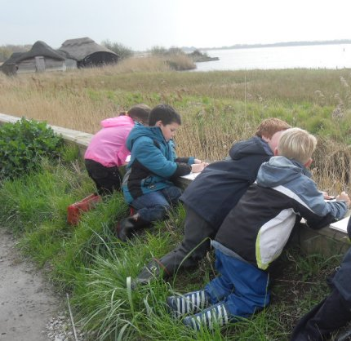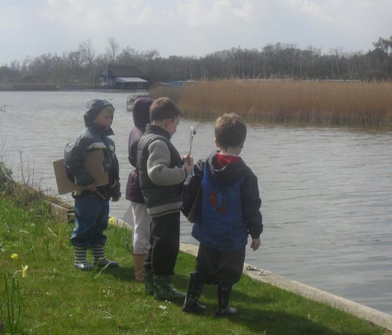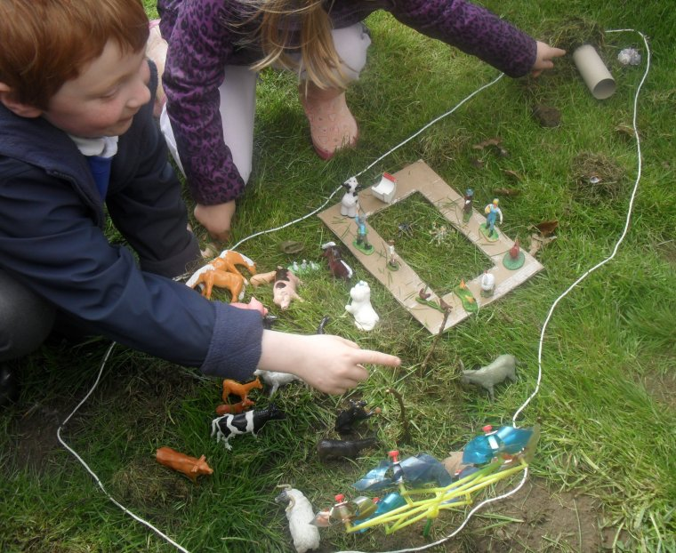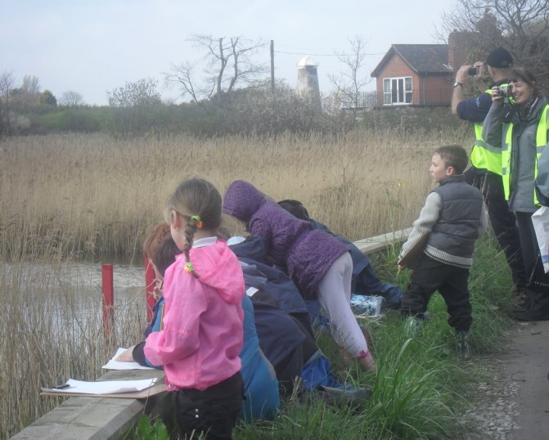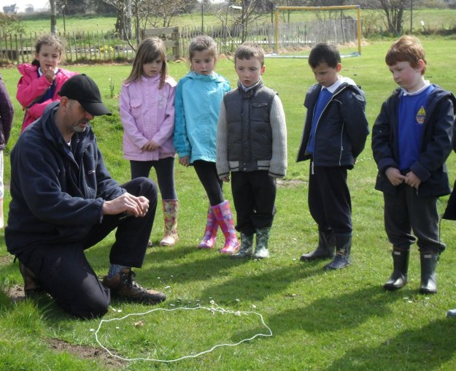

The Broads – Britain’s Magical Waterland
This teaching session and additional teaching ideas have been designed to help young children begin to understand and appreciate their local landscape.
It can be used anywhere in the Broads. The comprehensive notes accompanying the Powerpoint mean that it can be delivered by any teacher.
The session was first tried out with Hickling CE VC Infant School. We are very grateful to Deborah Hampshire and Jo Funnell for their helpful comments and additions.
The children worked on their paintings over several sessions. They were all put on show at a special exhibition in the village.
For more information and help with education work in the Broads contact Nick Sanderson, Broads Authority Education Officer: 01603 756089
nick.sanderson@broads-authority.gov.uk

Introduction
This resource is part of a Broads Authority project aiming
to help people really notice and understand the idea of landscape in the Broads and to experience it directly.
The approach was designed to be a mix of theory and practice, at a scale and pace which young children could take in.

Learning objectives:
To give the children an understanding of:
- What a landscape is
- What elements contribute to a landscape.
- What their local landscape looks like and why it is special.
Key Words Landscape, special, protected, lake, river, mountain, wildlife, building, view, holiday, flood, thatch, background, foreground.

National Curriculum Links:
Early Years Foundation Stage: Communication and language (listening and attention; understanding; speaking); physical development (moving and handling); understanding the world – people and communities; expressive arts and design - being imaginative.
Geography: ask geographical questions; communicate in different ways; observe and record; use fieldwork skills; describe what places are like; recognise how they are changing; study at a local scale.
English: Using language to explore their own experiences and imaginary worlds; attentive listening and response; interacting with others in play and to get things done. Speaking clearly and fluently, listening, understanding and responding; asking questions. Group discussion and interaction.
Art and design: Record from first-hand observation, experience and imagination, and explore ideas; represent observations, ideas and feelings, and design and make images and artefacts; working on their own, and collaborating with others, on projects in two and three dimensions and on different scales

Note
The photos which the children take and photos of their sketches and final art pieces will work well as part of a display and can be used in their record of achievement.

Activity | Resources
- Introduction: what is a Landscape? (10 - 15 mins)  Talk to the children about what a landscape is, illustrated by pictures on Powerpoint | - Powerpoint pres. “Britain’s Magical Waterland and YOU!”  - Smart board + linked laptop
- Build a Mini Landscape (in school grounds) (30 mins)  - Working in small groups (2-3 children) use natural materials to set out an area, and build a ‘magical landscape’, on a small scale. Use the string as a boundary.  - Add toy figures (animals and people) in to the landscape,  - Use small frames or kitchen roll middles as viewfinders, to see what a landscape looks like from different perspectives, and what features contribute to the landscape.  - Each group then gives the class a ‘guided tour’ of their particular mini-landscape explaining its highlights. Discuss “Would you like to live there?” | - An area which children can use for creative model making  - 2-3m lengths of string – one for each group  - Natural materials (grass, tree bark, leaves, etc)  - Toy animals  - Toy people  - Small frames or kitchen roll middles  - Camera to record activity
- Human Camera (in school grounds) (10 mins)  with older children  - In pairs, one child (the human camera) closes eyes and is carefully led by another child (the photographer) and pointed at a view. The photographer then gets the camera to open their eyes for 5 seconds. (Suggest they touch the camera’s ear for that time). The camera then closes their eyes, and is turned around. The camera then describes the view they have seen. Reverse roles and repeat.  - Younger children can do a similar activity using either frames or cardboard tubes. | - An area in the grounds with interesting / varied things to see
- Soak up the local landscape (90 mins)  - Walk to a place with good vantage points  - Look at the view, discuss what we can see (refer back to Powerpoint)  - Choose a viewpoint and sit down to make sketches (can also take photographs)  - Return to school | - Location with view of varied elements of the landscape; (needs enough space for the children to fit safely)  - Risk assessment  - Camera/s;  - Paper and pencils, Clipboards  - Carrier bags to sit on  - Sufficient adult support  - High visibility jackets for adults + children
- Create pictures (variations) (several sessions)  - Each child uses sketches to make a painting - A1 size paper seems to work well. Start with background.  - Experiment with cutting a photo into strips and mount the strips with gaps between, ask children to fill in the gaps  - Experiment with using things found in the landscape to print or paint with (reed lends itself well to this)  - Introduce texture into the pictures - make a collage e.g. with plant material found in the landscape | - Art materials  - Printed photos of the views  - Plant material from the landscape
Further suggestions:
- Thinking about change
Look further at your mini-landscapes and discuss various possible changes. Discuss the question “What if .... trees grew up? new houses are built? water levels rise? “
- Make a mini-wetland or What happens in a flood?
Children build a mini landscape in a tray then add water. Perhaps build a moat (good example of a memorable word with the ‘oa’ sound), then add water – will it collapse? Could film it. Good practice for science to get into the habit of predicting what will happen, then asking whether the prediction was right.
- Class Painting / Stage backdrop
Look at a landscape painting of the Broads and describe it – what’s in the foreground, the middle distance - the far distance? Compile together a list of the sorts of things you would find in a modern view of your local area. Each child then takes one of those landscape elements to paint. Decide on the background and paint it. Arrange the individual elements into one big combined image.
- Now and then
(a) History Go out with an old photo of your local street/village/park/Broad and try to find the exact spot the photographer stood. Can you find two things in the landscape which are different now and two which are the same? Take a photo of how it looks now. What changes have happened? Why do you think they happened?
(b) Seasons Go out with a photo of your local area in a different season. Try to find the exact spot the photographer stood. Can you find two things in the landscape which are different and two which are the same? Take a photo of how it looks now. What is different? Why? (Hint: Look out for seasonal human things as well as natural ones – people sitting outside a pub?, ice cream signs? etc.)
- Eat the view
What things in your local area can you eat? Are there crops you could sample? (Ask the farmers first). Are there grazing animals which end up as meat you could cook together?
Look at the hedges – are there blackberries? wild apples? hazel nuts? Take a walk to collect blackberries and make a crumble. Other berries and seeds may be good for art work.
- Celebrity guided tour
Choose a celebrity you would like to take round Hickling. Prepare for your tour (what will you show them? What tell them?). Other children play the part of the visiting celebrity.
- Holidays in the Broads
Look at old adverts or posters of the Broads. What things about the landscape did the poster-makers think were important? What sorts of things could you do on your holiday there? Does it look like somewhere you would like to go? What things about your local place would you put in a poster nowadays to advertise it?
For older children
- Our square mile
On a map or aerial photo of the local area draw a square round your school a mile across (or 2km or whatever size you want to cover). You could use Google maps/Google earth. Ask the children to think of everything they know about things within that local square mile, and write about or draw them. Ask them to include what they like or dislike about it. Over the next few weeks ask them to find out and record everything can about it. Make a display. (Extend the activity into the future to think about changes they’d welcome and changes they’d like to avoid)

- Views of the Broads - what can you do here?

Ask children to draw a giant pair of glasses. Then to draw a picture of the local landscape in one oval and a picture of what you can do here in the other one.
- Father Christmas comes here
Ask children to draw what Father Christmas sees when he flies towards their house/flies over the school.
Weblinks:
- Broads Authority (www.broads-authority.gov.uk)
- Nature detectives (www.naturedetectives.org.uk)
- BBC Class clips (www.bbc.co.uk/learningzone/clips)
- Maps (www.ordnancesurvey.co.uk/oswebsite/education-and-research/schools.htl)
- Maps (www.walk4life.info)
- Understanding local landscapes:
Landscape Character Assessment - Broads Authority

User Guide | Landscape East

Natural England - National Character Areas – defining England’s natural boundaries

