Love your Local Landscape:
Broads powerpoint slide show.
These notes are designed to accompany the Broads Landscape presentation, and are aimed at assisting teachers deliver the lesson to KS1 and 2.
- The Broads is one of the UK’s very special places.
It’s got the name ‘National Park’ – and there are only 15 of them in the whole country. You’ll see a map of them in a minute. National Parks are areas of countryside which are protected in some ways but which everyone can visit, and where people live, work and shape the landscape
Each National Park has its own organisation that looks after the landscape and wildlife and helps people enjoy and learn about the area. In the Broads it’s called the Broads Authority.
- Here’s a map of all the National Parks , and a map of where the Broads is.  - And we are….. where? Get someone to point out current location if they know.  We’re close to the coast.  Has anyone visited any of the others? … (Point to them on the little map) | 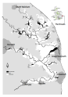
- In the past, the area which is now the broads was an estuary, a place where rivers empty into the sea. Most of the area around here was under water 2,000 years ago. Roman ships would have been able to sail on rivers which were over a mile wide. It would have been a very different landscape to that which we see now. What is a landscape? | 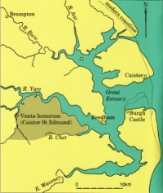
- Some people think the word landscape is only for places like this.  Most of the National Parks have landscapes like the one in this picture, but the Broads is a bit different.  - What can you see in the picture? mountains, lakes, trees, forest, rocks…..  It’s a beautiful place and it is one kind of landscape…. | 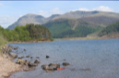
- But landscape also means this. Use a very local picture  This is our landscape.  - What can you see here?  (Prompt if need be - Landscape is not just nature. It contains lots of things – including buildings, roads, animals, pylons etc.  (… a water tower, church , lighthouse) | 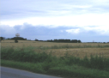
- What is this picture? (actually Filby Broad, Rollesby, Ormesby looking NE towards the sea)  - Who or what might see this kind of view? (A bird or someone in a plane).  - Can you see the sea?  Look at how much water there is in the picture.  When you get above the Broads you see how important water is in the area.  The lakes that we now call the Broads were dug by people about 1000 years ago, when the land was drier. They were digging peat from the ground for fuel, and left holes which flooded, and became the Broads. | 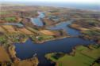
- Use a local aerial view.  Here’s view nearer to where we are now. (This is Hickling Broad looking SE towards the sea).  - Can you see the sea?  - What else can you see in this landscape? (Fields, trees, lake, houses, pond, hedges, farms, boats, wind farm. We’re building up a great collection of Broads-related words). Landscapes offer us lots of things.  - How many of you have ever been onto the Broads? What do you remember seeing? (Canoes? sailing boats? motor boats? reeds? Birds?)  This is what Hickling Broad looks like now. (or c. 2 years ago when Mike Page went up in his aeroplane and took the photo) | 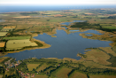
- Do you think this is a modern photo?  - What tells you it’s an old picture? (Black and white, old-fashioned mill, sailing boat, no motor boats, scruffy-looking cow with horns?)  Landscapes change over time. | 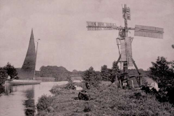
- A modern photo – but people doing something from the past.  It’s an activity that’s been going on in the Broads for hundreds of years.  - What do you think they are doing? What is the long pole is for? (The man is trying to catch eels with a special multi-headed spear. Eels can grow quite long and fat (typically up to c.60 cm long) and are full of protein, so they used to be a valuable addition to the local people’s diet. They could also be sold. The metal prongs have barbs on the side edges so that the eel is held tight between them and can’t wriggle away.)  Most people used to get most of their food and income from local places. It is said that 150 years ago, 2 hours of spearing eels would feed a family for 2 weeks! | 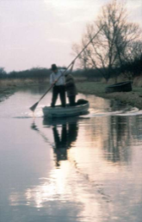
- Also a modern photo but showing two old boats.  These boats (called wherries) were once very common on the Broads.  Up until 100 years ago they were the equivalent of the big lorries which now carry all the goods we need to move around the country.  The one on the right is the trading wherry Albion (it used to carry flour and salt and beer-making materials between Bungay and Yarmouth). On the left is the pleasure wherry Hathor. These were used to carry people rather than things, so they had cabins and windows. People had holidays on them.  - What did they use to move the boats along? (sails + the wind). Trees had to be cut down along the river banks to stop them sheltering the waterways from the wind. The boats needed the wind to fill their sails to move them along. This made the landscape very open.  - What do lorries use? (Diesel) and how has the use of lorries affected the landscape? ( Roads) | 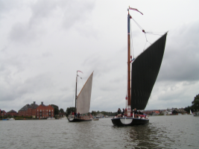
- Here are some people enjoying sailing near How Hill.  What’s the other structure in the picture which uses the wind? (a windmill or windpump - known as ‘Boardman’s windmill after the person who paid for it)  - What does it use the wind for? (Draining the land to make it dry enough for cattle and sheep to graze).  These ‘skeleton’ mills were a later and less expensive alternative to a brick windmill. Because they were built of wood the weather has destroyed most of them. Very few have survived. This is one of only three like this left in the Broads.  - Do you ever go out on a boat on the Broads?  - What do you like to do in the Broads?  - Why do you think people like to come on holiday here? | 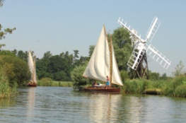
- The next few pictures concentrate on the wild, wet parts of the Broads landscape. Water is what makes the Broads so special.  There are 7 rivers, 63 broads and 120 miles of waterways that you could travel on in a boat. (That’s the equivalent of going from Hickling to Great Yarmouth and back four times).  - Do you know what the plant in the foreground is? (White water lily – it tells you something about the water in this broad. It can only grow in clean water.)  One of the things the Broads Authority work hardest on is keeping the water clean.  - Can you think of some things which might pollute the water? (Sewage; farm chemicals and slurry; oil and anti-fouling paint from boats and boatyards….) | 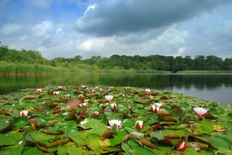
- Other wildlife which needs clean water.  - What is it? (Norfolk hawker dragonfly). Have you ever seen one? What do you know about them? (Dragonflies like this live under water for 2 years before they come out and fly around. They eat other little animals and need clean water to be able to see their food.) | 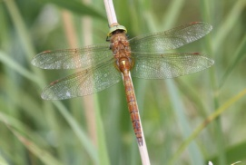
- Pike  - What is it? (Pike) Have you ever seen one? What do you know about them? (They eat other fish, frogs and ducklings, which they catch by lying in wait and pouncing on them. They need clear water where plants can grow – so that they have something to hide in. ) | 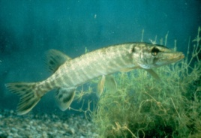
- Kingfisher  - What is it? (Kingfisher). Have you ever seen one? What do you know about them? (They eat fish and need to be able to look down into the water and see what they’re trying to catch. ) | 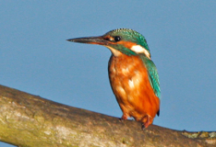
- Otter  - What is it? (Otter) What do you know about them? (They eat fish and need to be able to see what they’re doing underwater. They were extinct in this area for almost 40 years (because of pesticides) but numbers are now increasing. They leave their droppings (called spraint) in obvious places (can often be found under bridges) to mark their territories. The droppings smell fragrant – some people say like jasmine tea or sweets called Parma violets). | 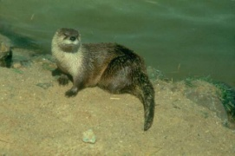
- Reeds  - A remarkable plant which likes to have its “feet” wet. It is a very special kind of grass. It grows all round the broads and along rivers and ditches. Long, strong, hollow stems. Living in a reedbed must be a bit like living in a miniature forest - very sheltered, but very wet. | 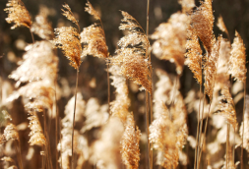
- Cutting reeds. Another job lots of people used to do in the Broads. When they cut the reeds they also cut down any young trees which were trying to grow. This kept the landscape open.  - What do you think he wants those reeds for? (The traditional use for reed was as thatching material for roofs.) | 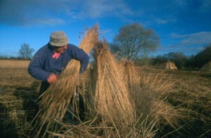
- Thatch – (two boathouses on Hickling). People have been using reeds to make roofs for their houses and sheds for thousands of years. It makes a strong, waterproof, lightweight roof – which doesn’t need to be brought from miles away by lorry. It’s a nice colour and fits in well with the landscape.  - Has anyone got a roof on their house made out of reeds? Has anyone ever seen thatchers working? | 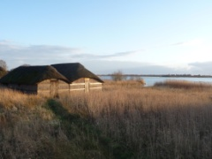
- Reedbeds are now uncommon, so the wildlife which needs reeds is uncommon too. It’s easy to forget this when we live in/near the Broads.  The next pictures are of rare and wonderful wildlife which needs reedbeds,  without reeds they would disappear.  - What is it? (Bearded reedling or tit). Have you ever seen one? What do you know about them? (Bird with a moustache = bearded tit or reedling. Nests low down among the reed stems – very sheltered.) | 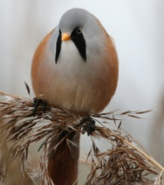
- Bittern.  - What is it? (Bittern). Have you ever seen one? What do you know about them? (A brown kind of heron who eats fish - and frogs and insects sometimes). It’s a very secretive bird but the males make an extraordinary loud booming noise in spring. It’s one of the most threatened birds in the UK - because reedbeds are rare. | 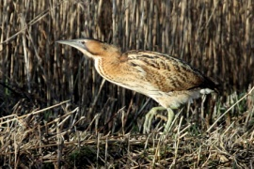
- Marsh harrier  - What is it? (Marsh harrier). Have you ever seen one? What do you know about them? (A big bird of prey which eats small mammals, small birds, insects, reptiles, and frogs. Females are much bigger than males. Forty years ago they were almost extinct in Britain (down to 1 breeding female,) as a result of pesticide use, persecution and loss of their wetland habitats. Now numbers are rising again and in places with lots of reeds you can often see them flying low over the reedbeds, hunting.) | 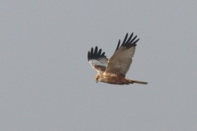
- Swallowtail butterfly  This is Britain’s largest butterfly and is now found only in the Broads.  - Can you see from the photo why it got its name? (Forked tail a bit like a swallow). They have just one plant they lay their eggs on – milk parsley. They became extremely rare when the reed and sedge stopped being cut (after the Second World War). Nowadays active reedbed management is helping them. They are still rare but you can hope to see them at Hickling, Ranworth and How Hill if you go at the right time of year (usually late May– to mid July), and you have a bit of luck. | 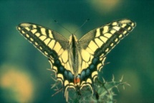
- Berney Arms Mill – a classic part of the Broads scenery.  - What is it for? (Like most of the other mills in the Broads it was used for scooping water out of the marshes into the river to make the land dry enough for cows and sheep to graze it.)  - What makes it work? (The wind). This is one of the tallest and highest ones in the Broads. If the land wasn’t so wet, no one would have built these windmills – a good example of the landscape affecting the shape of the buildings which then affect the landscape! | 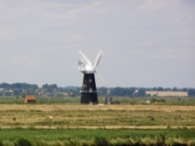
- Cow/bullock?  - How do they affect the landscape? What do they need? (They need grass and water – so that’s what they are given. Raising cattle is one of the only ways to farm the low-lying grasslands alongside the rivers in the Broads. Without management these wetlands would turn into willow scrub.) Farmers are (at the moment) paid extra to farm these grazing marshes in a way which aims to have less harmful effects on wildlife. | 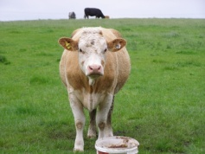
- Barn owl  - What is it? Have you ever seen one? What do you know about them? (They like grazing marshes where they can sit on fence posts or cruise on their long wings listening out for voles and mice). Can you see this one’s long legs? They’re good for reaching down into the grass and grabbing something for dinner! On average a wild Barn Owl may eat about 4 small mammals per night and it hunts by hearing its prey. If the grass is too long it stops the owl from catching mice and voles because long grass is noisy in the wind! Cows act as living lawnmowers, keeping the grass short and making it easy for Barn Owls to find food in the marshes. | 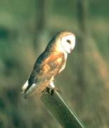
- Alder Carr  - Is it a pond or is it a wood? (The truth is it’s a very soggy woodland with trees growing in water and mud). It’s called carr woodland and is a classic part of the Broads landscape. It grows at the edges of the Broads’ lakes and rivers and on old fens which have not been cut.  - Why do you think it’s so very undisturbed? (The liquid mud between the trees can be several metres deep so it’s impossible to go for a walk there). Lots of rare insects specialize in living in carr woodland. The main trees are alders and willows which can cope with having their roots in water.  - If no-one looked after the Broads by cutting the reed and marshes, and letting cows graze, Alder and Willow trees would grow all over the area and it would all become wet woodland. Nature would totally change the landscape! | 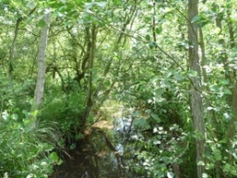
- Sunset + river wall  In an open landscape like the Broads you get to see a lot of sky.  - What do you think the big bank of earth on the right is for? (In many places in the Broads the rivers are higher than the land, without earthworks like this river wall the water would spread out over the land.) Flood protection works like these need regular inspections and repairs to keep them in good order. As sea level rises there will be changes to the Broads area’s landscape. ….. | 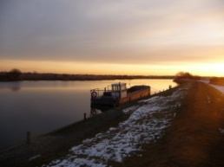
- Mill and reedbed and winter trees  The Broads is beautiful in all seasons.  - How many things can you see in this picture which help you to know that it is the Broads? (Windmill/pump, alder trees, river, reeds. big sky, higher land in the background with trees) | 