Life Jackets Save Lives

Lifejackets and Buoyancy Aids are sometimes called Personal Flotation Device (PFD). PFDs are measured in Newtons. A Newton is a measured unit of Force and the higher the Newton rating is on a PFD the higher the buoyancy rating.

Buoyancy Aids

A buoyancy aid (Not a life jacket) looks like a padded waistcoat and should be made of closed cell foam with a simple, secure zip or buckle. Buoyancy aids are ideal for use in sheltered or inshore waters to provide a degree of buoyancy in a lightweight garment. They will only provide limited protection against drowning.

Lifejackets

Lifejackets are available in a wide range of colours, specifications and different CE classifications. There are many reputable lifejacket manufacturers supplying the leisure marine market. Below are the new ISO standards being introduced in to the UK during 2006.

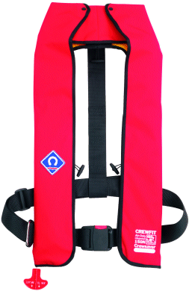

A lifejacket has the advantage that, when fully inflated, it will turn an unconscious person to float upwards, with mouth and nose clear of the water.

When purchasing a jacket be sure that you are aware of how to fasten it securely and of its limitations. Unfortunately lifejackets are often left in a locker somewhere. Many would say its because they are uncomfortable and cumbersome to wear. This is not true. A properly selected lifejacket should be comfortable and you should hardly notice you are wearing it. Comfort is an essential consideration if you are to wear your like jacket regularly. Your lifejacket will not save your life if it’s stored away somewhere – so please wear it!

Most good manufacturers/suppliers provide good descriptions regarding typical use, weights etc. and will help you to decide which lifejacket is right for you.
It is essential that you wear the right lifejacket for the job at hand and never wear anything on top of your life jacket.
Servicing/Care of your lifejacket
It is recommend that a qualified agent should service automatic lifejackets at least every 2 years but preferably every year. Regularly inspect your lifejacket for wear and tear. Follow the care procedures as described in your owner’s manual.

Your lifejacket will provide many years of service, provided it is cared for correctly.
Generally lifejackets should be cleaned with a good quality mild detergent in cool water. Rinse well with clean water and allow to dry naturally. Sponge off contaminants such as oil or diesel immediately with clean water.
Lifejackets fabric has protective coatings and these will be damaged by proprietary cleaning fluids, thinners, spirits or similar substances.

Enjoy your water activities but do please keep safe.

